Apple Farro Risotto
(with fried mushrooms and foraged greens)

By Brian Porter

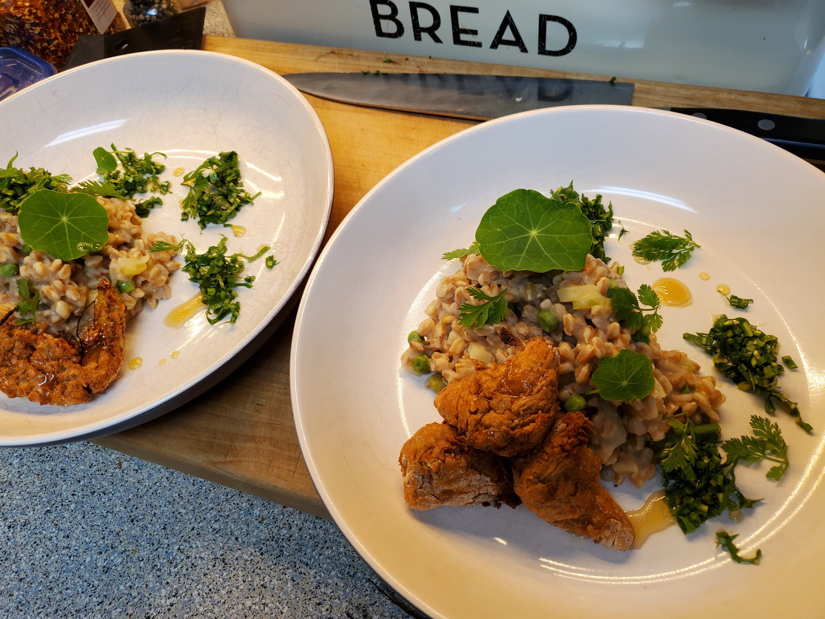

I broke this recipe into three parts. Basically, we’ll be making a farro risotto, fried mushrooms, and a salad dressing for the greens.

Farro Risotto

1 pint of Farro (dry)
2 ounces of butter
1 carrot,small dice
1 onion, small dice
1 stick celery, small dice

1 pound of apples
1 bouillon cube
1 tsp of Fennel seeds
1 tsp of Ground Black pepper

First, boil the farro in a copius amount of unsalted water, just like you would with pasta. Let it cook until it is al dente (slightly under cooked).
As the water heats up for the farro, begin cleaning and chopping up your apples. Keep the skins on, but remove that stem and seeds. Place the chopped apples, bouillon cube, fennel seeds, and black pepper into a small pot with a cup of water, bring to a simmer, then cover the pot for about 10 minutes.

While everything is cooking, dice up your mirepoix (onion, carrots, and celery).

Once the apples in the small sauce pan have cooked (softened a bit), blend it all together on high speed. You will need about 3 cups of this apple puree. If you don’t have three cups, add water (or vegetable stock) until you’ve reached three cups.

Strain the boiling pot of farro into a colander. Put the pot back on the stovetop and add the butter to the now hot and empty pot. To this, add the mirepoix and cook until the onions are translucent.

Next, add the apple puree to the pot, and the farro over that. Add at least a tablespoon of salt and stir it all together.

Taste it and adjust the seasonings (salt/pepper, other)

TIp: I prefer tart apples for this dish, but other apples work. If you want a little more tartness try adding some of the apple cider vinegar to your apple puree.

Air Fried Mushrooms and Baby Corn

1 cup flour
½ Tablespoon garlic powder
½ Tablespoon salt
1 tsp cayenne

1 cup butter milk

4 oz of mushrooms or baby corn

Turn the air fryer on to 360 F

Tear or cut the mushroom into desired shape and size. Try to be consistent, that way all the pieces will cook at the same rate. Soak them in the buttermilk for a little bit.

In a small bowl, mix the flour, garlic powder, salt and cayenne together.

Spray or brush the airfryer tray with oil, and then start battering your mushrooms.

To batter the mushrooms, take them out of the buttermilk, let them drip, then dredge them in the flour. I double coated mine, but for the size I made them, a single coating would have been perfect.

Cook them in the air fryer for 5 minutes. After that, cook them again for 4 minutes right before plating.

Terroir Greens

Dandelion Greens (chiffonade)
Cilantro (plucked)
Nasturtium Leaves (plucked)
Green Onions (rings)

1 Tablespoon Apple Cider Vinegar
½ Tablespoon of brown sugar
Pinch of salt
2 Tablespoons olive oil

Pluck and slice your herbs, keeping them on a plate and off to the side.

Slice the dandelion greens and put them in a small mixing bowl.

Mix the dressing (applecider vinegar, brown sugar, salt, and olive oil) in a separate container.

Dress the dandelions with some of the vinegar mix, but reserve the rest for spooning over the plated dish.

To Plate:

Spoonfuls of the farro go down on the plate, the fried mushrooms get place next to that, then the dandelion salad gets placed in small stacks around and on the risotto, then the remaining garnishes get placed neatly with tweezers. Last, I take a small spoon to deposit the rest of the dressing all over the plate.

