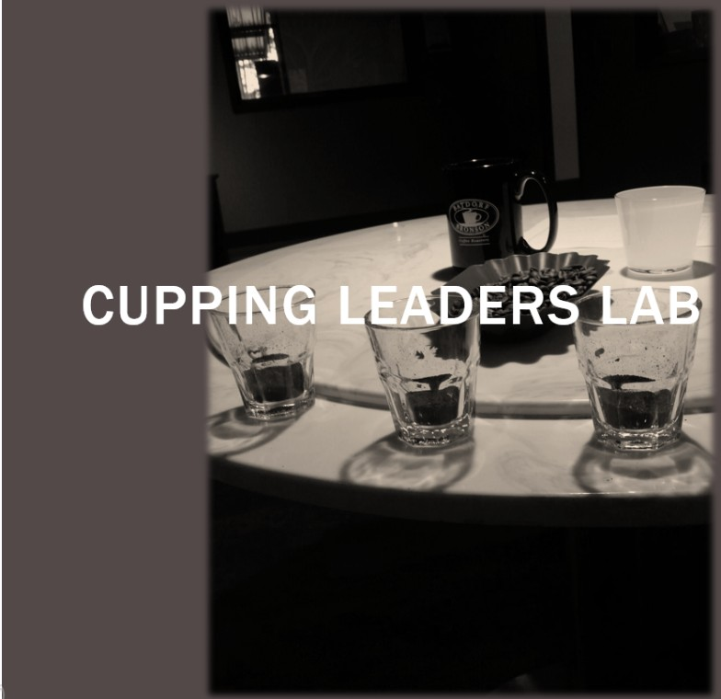

A hlow iTo
Guide

Specialty Coffee Association of America Coffee Cupping Form
Q11ality scale :
6 00 | 7 00 - | 8.00 -Specialty | 900-
6.25 | 7.25 | 8.25 | 9.25
6 50 - Good | 7 50 -Very Good | 8 50 -Excellent | 9 50 -Oustand1ng
6 75 | 7 75 | 8.75 | 9 75

Name·

C OAL T Y
C O F F EE A SS O C I AT IO N
Date:

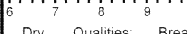□
Score:
Clean Cup
□□□□□
Score·
Unifor mi ty
□□□□□
Score·
Score:
Score:
Score:
Flavor
Body
Overall

Sample # Roast
L.e,vel
S a mp le
1
06 7 B 9

6 7 8 9
7
Defects (su btract)
Score:
Sweetness
□□□□□
•
10
Tota l
Score
II I I II I I II I I II I 1
II I I II I I II I ii I I I
II I I II II II II II I 1

Taint=2 # cups Intensity Fault=4
6 7 B 9 10
I I I I I I I I II I ii I I I I
Balance
Score .-
6 7 B 9 10
II 11 I I I I I I I I II I I I
Aftertaste
Score:
Heavy

Thin
le vel
I
High

Lo w
In tensity
I
□ □
i

O x =

Notes .- Final Score
□

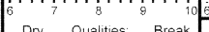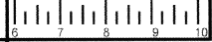To ta l
Overall
Score:
Scor:e
Clean Cup
□□□□□
Score:
Unifo rmity
□□□□□
Scor:e
Score:
Flavor
Scoer·
liloHt
L.e ,vel
Sample

i
Sample #
Score
7 8 9
II I I II I I I 11 I II I 1
Defects (subtract}
Score
Sweetness
□□□□□
Score:
Score:
Level
I
Intensity
I
Taint=2 # cups □Intensity□
6 7 8 9 1 0
II I I II I I II I I II I I I
Balance
6 7 8 9 1 0
II I I II I I I I I I II I I I
Aftertaste
Heavy

T hi n
High

L ow
Faul=t 4 O x
=
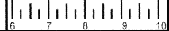No t es: Fin a l S core □
Overall
Score:
Score:
Clean Cup
□□□□□
Score·
Uniformity
□□□□□
Score
Score:
II I I II I I II I I II I 1
Flavor
Score:
Sample # Roau
Level Fragrance /Aroma
Tota l Score
ol I I I I I I I I
8 9
S am ple
I
I
I
I
I
I
I
I

6 7 6 9 1
Balance
Aftertaste
Score
Level
Intensity
H;gh
06
i
II I I II I I Iii I II I I I
Heavy

Th m
I
I

6 7
"
9 10
L ow

Defects (subtract)
Taint=2 #cups Intensity Faull=4
Scor:e
Sweetness
□□□□□
6 7 8 9
II I I II I I II I I II I I I
Scor:e
□ □

O x =
Notes: Final Score

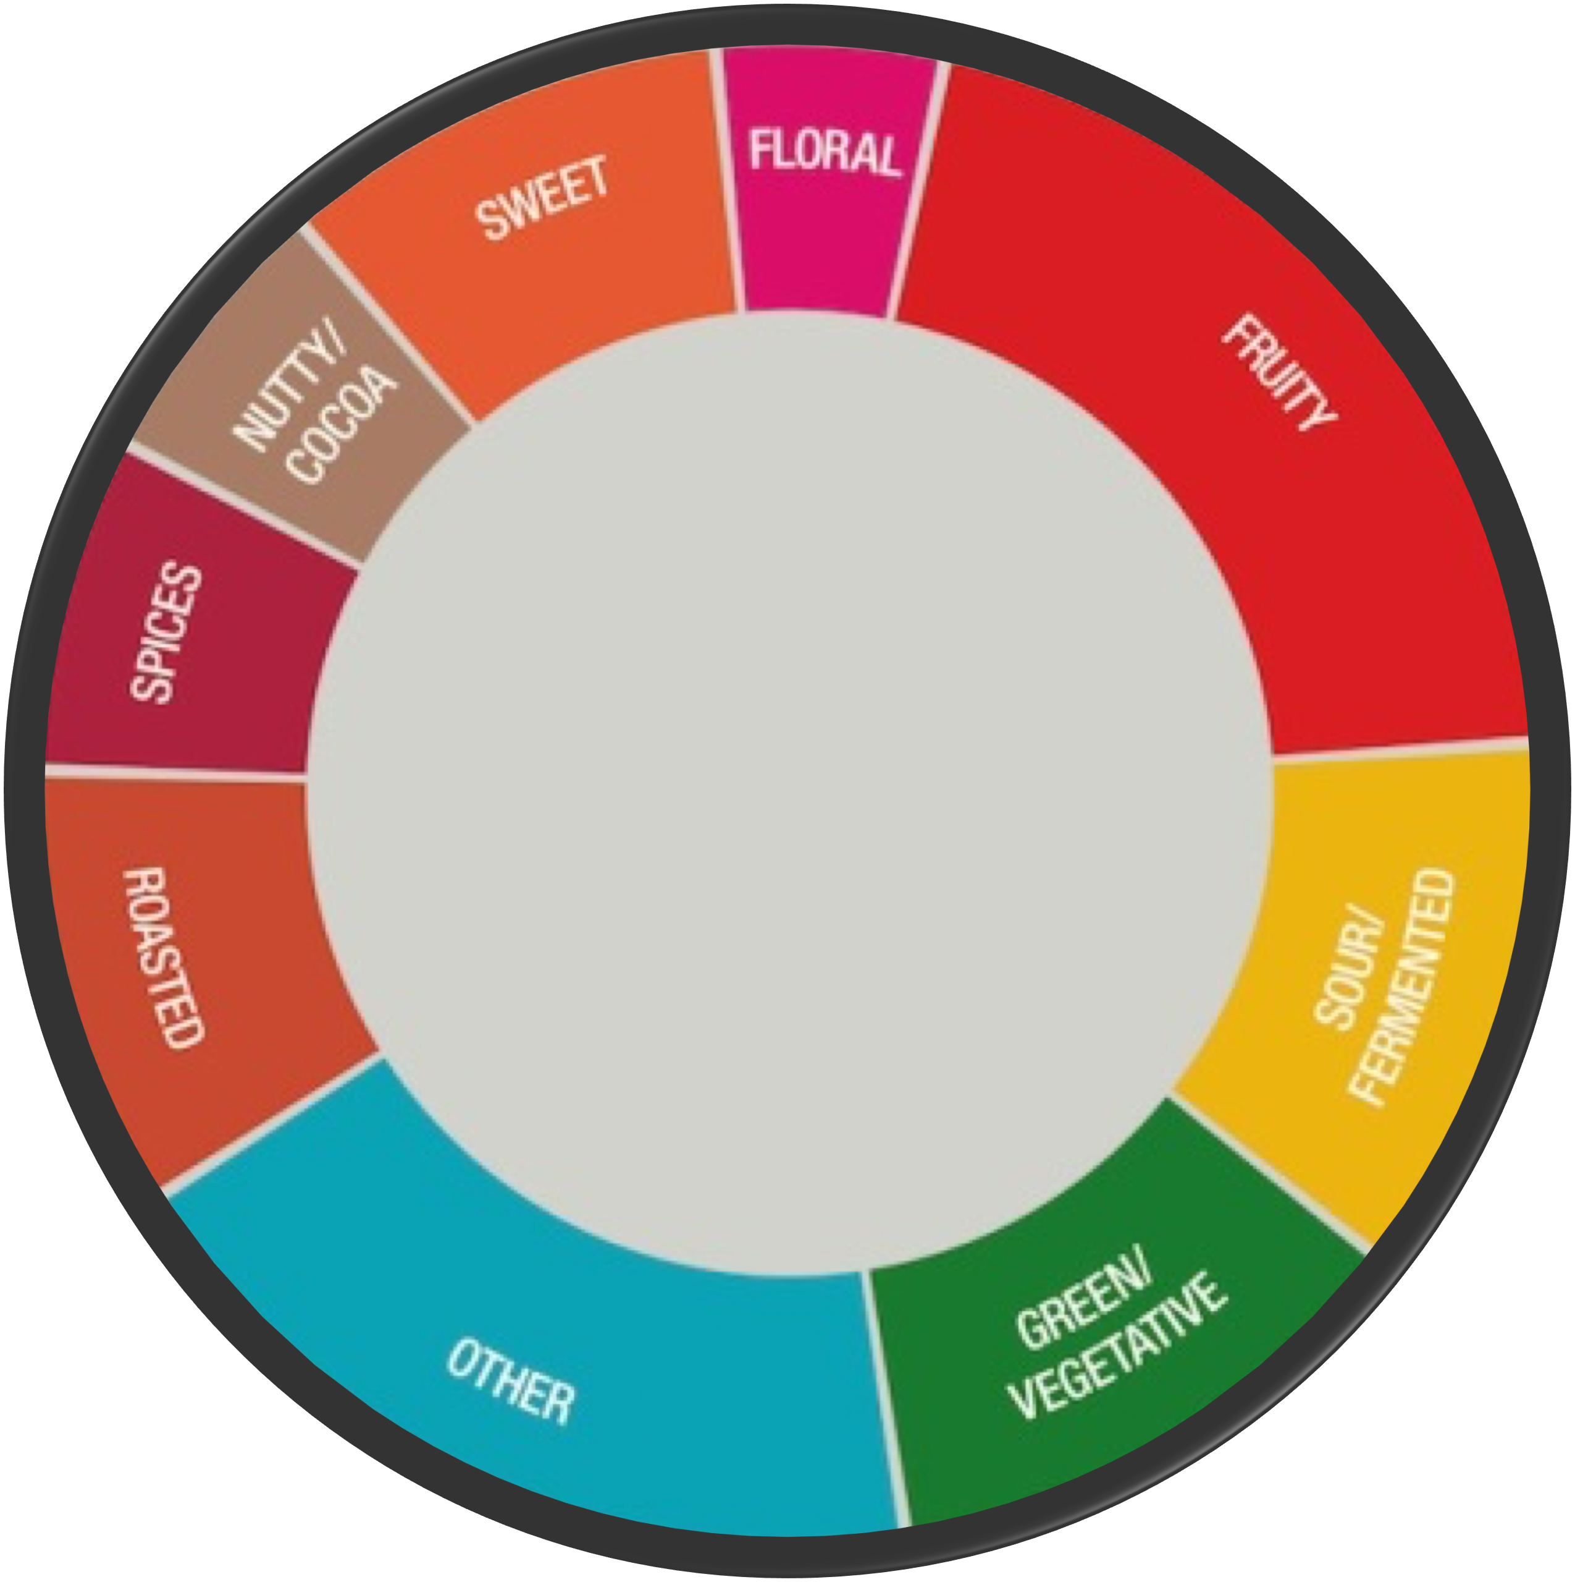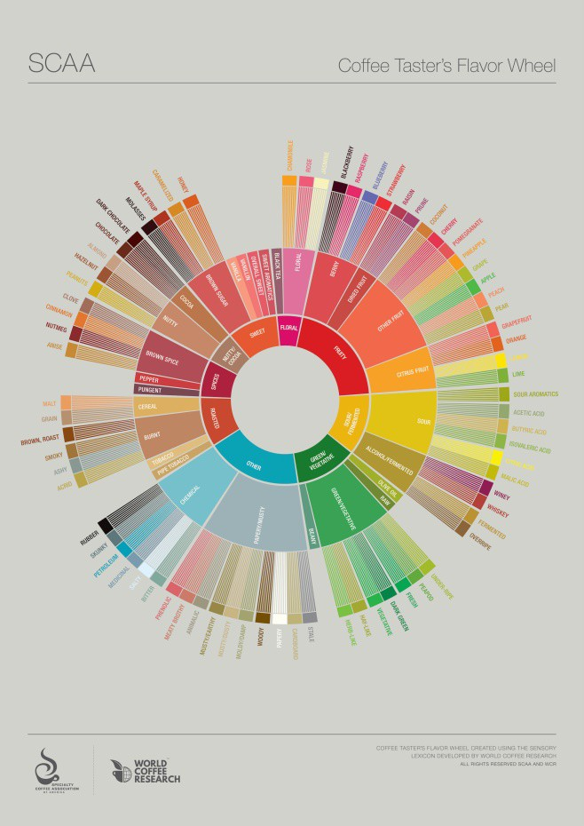How To Read the SCA Flavor Wheel
It’s not that bad if you know where
to start.

The Flavor Wheel can seem a little over-whelming at first…

The Flavor Wheel is designed to be read “inside-out”. The flavor notes on the inside circle are broad categories that can be broken down into specifics as you read outwards.


As you taste coffees, start in the center and branch outward. Consider this as well; when you are asked about a particular coffee by a customer, the notes found in the center circle may be all you need. Stay broad with your customers. If you see them again, ask what they tasted and then maybe take them further outside the wheel. It’s all about encouragement and building rapport!



- 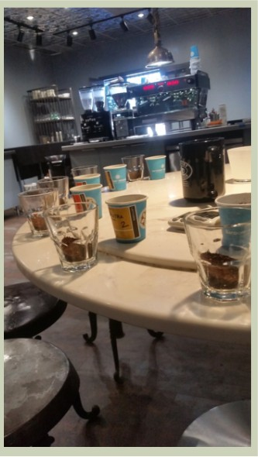Coffee
- Quality Water Source
- Gibraltar Glasses or Cupping Bowls
- Gram Scale
- Timer
- Grinder
- Kettle With Heat Source or Hot Water Tower
- Rinsing Bowl
- Cupping Sheets and Pens or Pencils
- Cupping Spoons
- Spittoons
- SCAA Flavor Wheel

Cupping Leaders Cheat-Sheet

- Fill 8 Grams of Coffee into a 5.5 Ounce Gibraltar/Cortado Glass.

  - 12 grams for Cupping Bowls

- Grind Sample on “French Press” Setting. Purge between grinds

- Have a timer ready before you pour.

- Fill Gibraltar (start your timer as soon as you begin pouring) to the top with water at proper brew temp (between 195-205 degrees F)
- Allow to brew for 4 Minutes.

- After the timer reads 4 minutes, Break using the back of your cupping spoon. Do not stir the bottom of the glass.
- Immediately clean surface grinds and try to remove surface foam.

- Allow time to Cool before tasting ( cups are usually ready by the 12 to 14 minute mark, use this opportunity to talk about your smelling notes).
- Slurp and take notes. Continue to slurp as the coffees cool and compare your notes. Spend as much time as you need

Cupping Form

Coffee | Fragrance | Aroma | Flavor | Aftertaste

Acidity
Body
Balance
Overall

Coffee | Fragrance | Aroma | Flavor | Aftertaste

Acidity
Body
Balance
Overall

Coffee | Fragrance | Aroma | Flavor | Aftertaste

Acidity
Body
Balance
Overall

Name __________________

Triangulation




Name ____________________

Cupping Leader’s Quiz

- Which portion of the brain is responsible for detecting smell and taste stimuli?
  - The Visual Cortex
  - The Prefrontal Cortex
  - The Olfactory Bulb
  - The Corpus Callosum
- Which of these is a competition in which “Cupping” is the source of evaluation?
  - Barista Championships
  - Cup of Excellence
  - Coffee in Good Spirits
  - Brewers Cup
- “Acidity” in coffee, in the context of cupping, is a measure of the coffee’s pH level.
  - True
  - False
- is the only category on the simplified cupping form in which the cups should be touched.
- An inexperienced cupper is having trouble putting into words what they are tasting, briefly describe why this may be happening. How you would encourage them to “find the words”?

- After the coffee is ground and ready to brew and your kettle is ready to pour, make sure you have a ready before you begin pouring.
- Having a good palate requires one to have a specific set of genes and a highly sensitive olfactory sense.
  - True
  - False
- A is a specific form of “cupping” that tests your ability to differentiate between two separate coffees in a flight.
- Circle correct answers in Parentheses. If a coffee is causing your mouth to “pucker”, you would give that coffee a (high/low) acidity score and a (high/low) balance score.
- Open Answer, What benefits can be gained from retail staff cupping regularly? How does it help your customers?

