SCAA Coffee Taster's Flavor Wheel

w
--'
:ii:

0:;; w
••
<(
"'
:c 0
'-' a:

c,1\11-? fl\lll
I

  - Ql\!l-llc,
I o,
I LIME

I SOUR AROMATICS
I ACETIC ACID
I BUTYRIC ACID
I isovALER1c ACID
  - CiTRtc Ac10
- /l,f4Ltc4Cto
WtNtr

"- • ••
Q. ,;,
i
,"..-_
fl
:;; >-
,n,
,,

c3"
0
r

,t,

,t,

i:.

"" ,.._
'2
i:::
0 :,:,
,:;: ⁰ C, "'
3:
"i:'.

:f;;l :f;l; 0s
:;;
0",,'
:,:,
C,

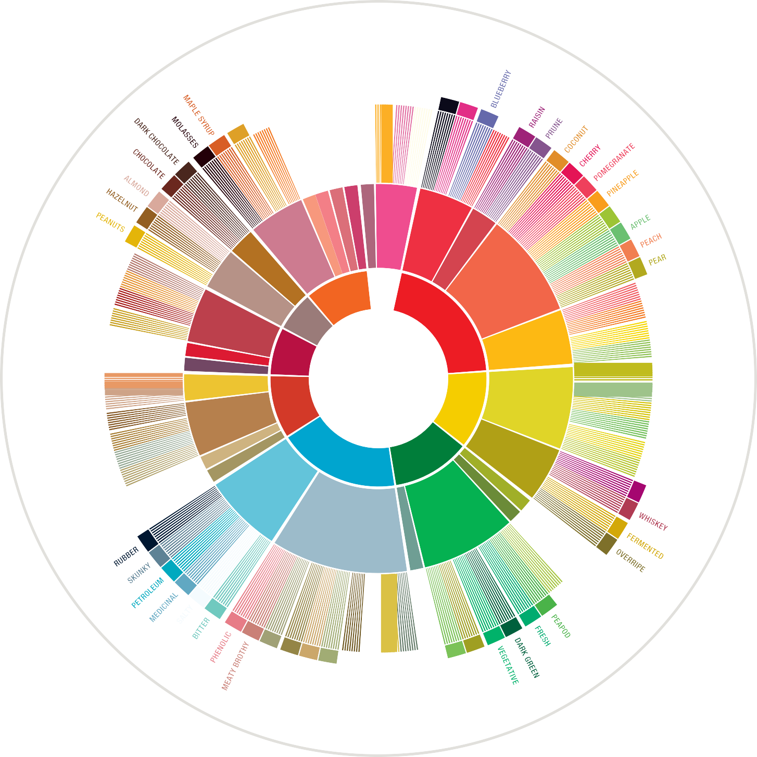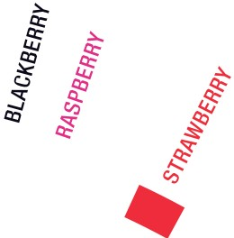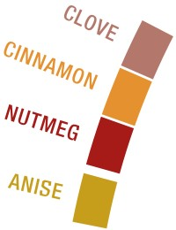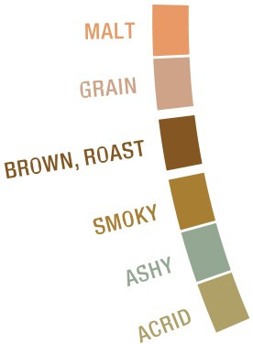

' WORL­D COFFEE
a ltt
'IIIIIIJ7 RESEARCH

COFFEE TASTER'S FLAVOR WHEEL CREATED USING THE SENSORY LEXICON DEVELOPED BY WORLD COFFEE RESEARCH
(Cl 2016 SCAA AND WCR

V.1

