Taste Book Experiment Guide #3
Week 6 – Sight & Sound Chapter
Pp 114, 115 & 131
Caleb Poppe; popcal18@evergreen.edu
We will be referencing Barb Stuckey’s book, Taste, again this week, and for those of you that have a copy of their own, please read through the Sight Chapter (pp 102-114) & the Sound chapter (pp117-130).
[Taste is a required text and available for $2 online. Caleb has provided excerpts as downloads on our Tasting Research website: https://wordpress.evergreen.edu/terroirw21/2021/01/02/3-coffee-wks-5-6/]
Supplies you’ll need:
- Several different light-colored juices or flavored waters.
- Several different choices of your favorite snacks.
- The 3 different food dyes that we provided to you.
For those of you that do not readily have access to juices may try getting creative with making your own juice or by flavoring your own waters at home with any fruits or veggies that you have, the key is to have a drink that has a very distinct flavor (i.e., orange juice or tonic water) but may undergo a change in color. Juices/drinks can also be purchased quite inexpensively at Grocery Outlet!
When it comes to snacks, choose anything that you enjoy but try and have an assortment of textures, if possible. For instance, a blueberry has a very different mouth sensation than a cookie.
Today’s Experiments:
- “Taste what you’re missing: Can Color Color Taste?” page 114,115
- “Taste What You’re Missing: Hear your favorite foods” page 131

Throughout these labs try and reflect on your own experience and perceptions, doing this will help you to answer the questions that coincide with this guide. It may help to have the answer sheet open so that you can record your thoughts and reflections while they are fresh in your mind. Above all, have fun.

It is true that smell and taste play undeniable roles in the experience of flavor, and one might even add that the visual appearance of food is a crucial aspect of our perception of eating, yet there must be plenty of folks that could not care less about how a meal looks and would happily dig in regardless of the plating; but the importance of sound, I feel, is often undervalued.
Whether it is the sound of the food that we are eating, or the sound of our setting’s ambience in which we are enjoying a meal, we as eaters are continuously making lasting connections between our food and our audible settings. To try and put this into perspective, think of eating popcorn at a movie theater; not only does the popcorn have a very specific sound when you bite into it (crunchy, yet squeaky) but just as specific and memorable is the sound of the hushed, excited whispers of other movie patrons and their own rustling bags of popcorn! All these subtle nuances may have lasting affects on you that go unnoticed until pointed out.

Now, there was no intent to glaze over the importance of the appearance of the food we eat, many fine restaurants believe that plating is crucial, in part because humans are artful and creative beings that are drawn to the unique and beautiful. The appearance of the food we eat undoubtedly influences how we perceive its flavor! Just think about the Great British Baking Show, how many times do the judges say “…hmm the flavors were all there, but you just didn’t quite nail the appearance.”? And to take this thought a bit further, what about not being able to see the food we eat? Individuals that are sightless will surely have a different eating experience than those that are sighted. Does this change how the sightless perceive food?

Sight and Smell, it is these two senses that we will delving into today. We will try and fool our own tastebuds by fooling our own eyes, and then we will see if we can discern our own snacks solely by the sounds they make while being chewed! Please follow through the steps of each of these experiments and then answer the questions from the corresponding week 6 question form.

1st Experiment: “Can Color Color Taste?” pp 114, 115
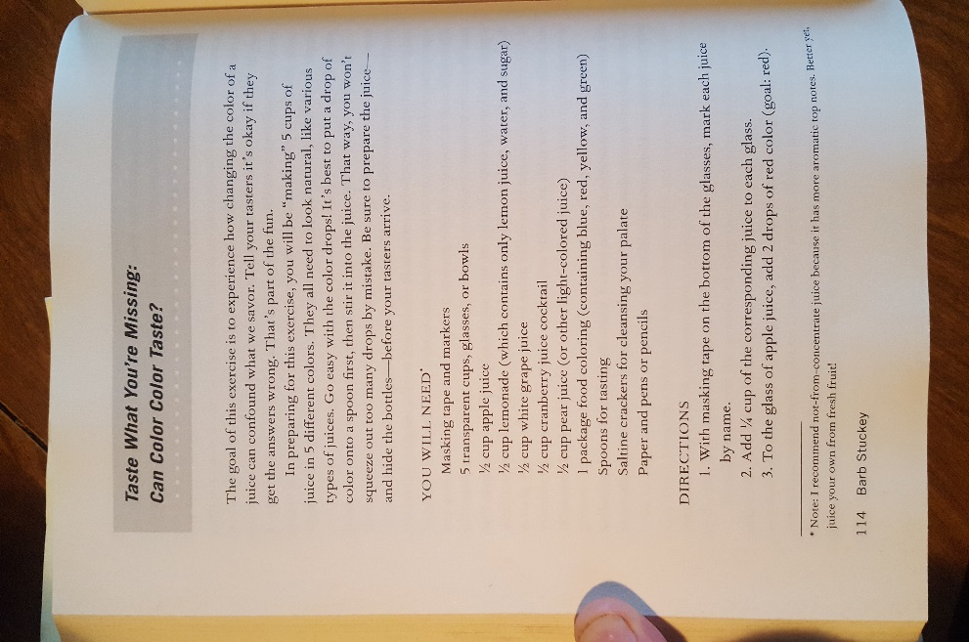
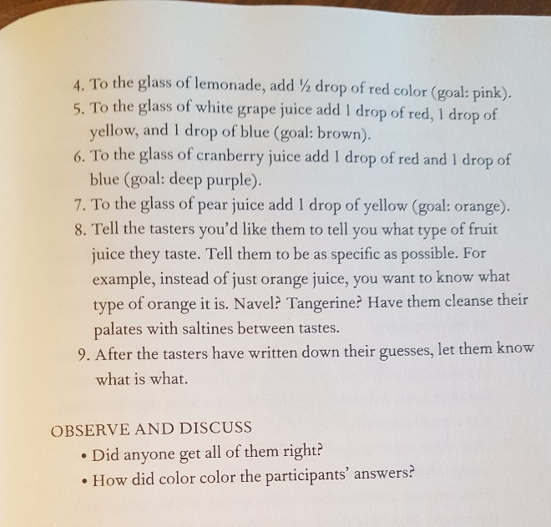

In this experiment we will be trying to fool our tastebuds by first fooling our own eyes. With the beverages that you brought to today’s experiment and the food dye baggies that I provided to you, you will be altering the color of your drinks until they are unrecognizable, such as turning your orange juice green, or your grapefruit juice a deep red.
Once you have the juices mixed and poured into separate glasses, you can begin to taste each drink one by one, paying keen attention to color before taking your gulp. Can you feel your mind wandering to different flavor ques in anticipation for the incoming beverage?

(Unfortunately, there will be an element of mystery missing from the whole experiment as we will be having to mix and change our own beverages, resulting in us knowing which color corresponds with which drink. Perhaps, if you have time, this can be done again with friends, family, or roommates in which you facilitate the experiment yourself!)

2nd Experiment: “Hear your favorite foods.” Pp 131

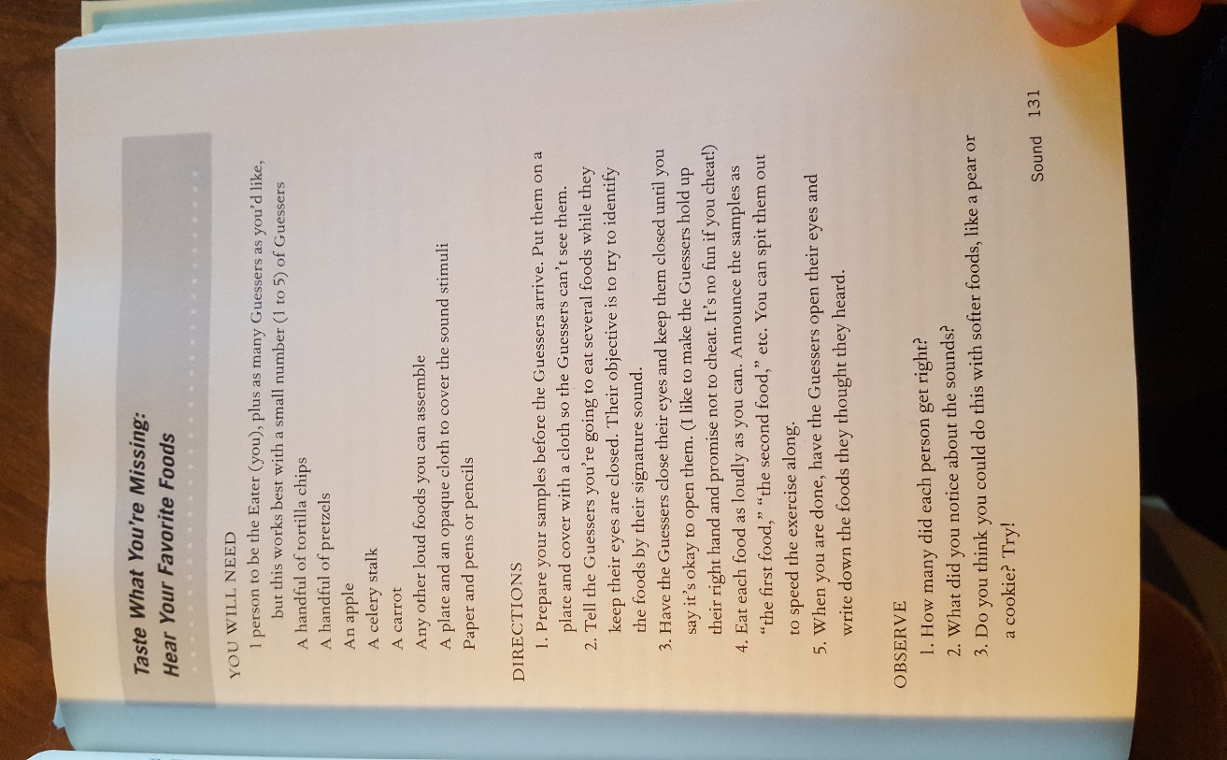

To prepare for this experiment all you will need are your snacks and your imagination. You will be released out into breakout rooms in zoom with 3 or 4 other students and, armed with your snacks, you will begin quizzing each other on the cacophony of sounds the emanate from your snack when being chewed; that is to say, you will guess which snack your peer is chewing! For the first round, be sure to keep your snacks a mystery to everyone in your group to see whether your partners can guess correctly, without having any clue as to what snacks you brought. Once one person has gone through each of their snacks, they can reveal what snacks they brought to the table.

**If there is time, we will do another where we do another round of loud chewing, but now we will have some idea as to which snacks are being eaten.**

