Geoduck & Seaweed Tasting
with @geoduckgal Emily Wilder
Needed:
- 4 mugs or canning jars
- Boiling water (during the 10:45am break)
- A thermos with additional hot water
- Seaweed samples
- Your favorite tea (black, green, or herbal)
- Dinner plans

GEODUCK “TASTING”
- WHAT DOES GEODUCK TASTE LIKE?

- WHAT IS “Q”?

- LABEL THE PARTS OF THE GEODUCK:
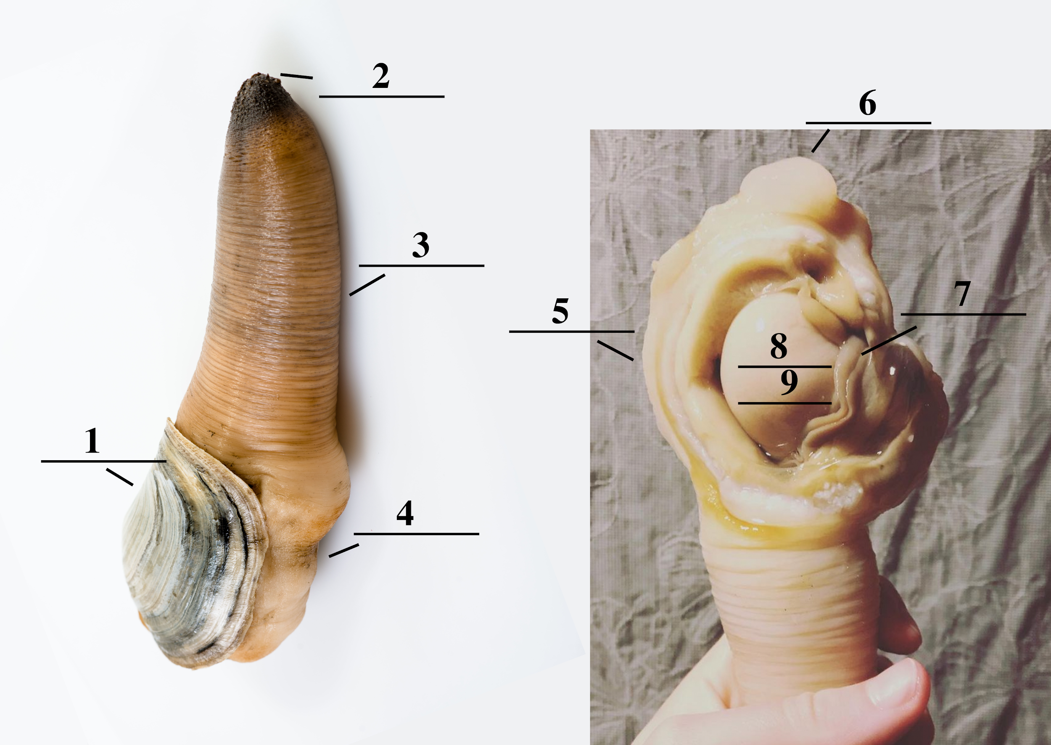

1.
2.
3.
4.
5.
6.
7.
8.
9.

BREAK TIME
Please heat up your water during this time, and set up the following 4 cups:
- One piece of kombu (roughly 3”x1”)
- A couple pieces of wakame (roughly 3”x1”)
- The equivalent amount of sea palm (about 8 pieces)
- Your favorite tea + a piece of wakame
When we return from the break, you’ll pour boiling water in each of the seaweed cups and let them steep while Annie tells us about her seaweed ILC. Wait to add water to your favorite tea until we start tasting the seaweed, so the tea is not oversteeped (it will be the last thing we taste).

SEAWEED TASTING

- WHAT ARE THE THREE SEAWEEDS WE ARE TASTING TODAY?

- WHAT TYPE OF SEAWEED ARE THEY?

- WHAT ARE THE HEALTH BENEFITS OF SEAWEED?

- WHAT IS THE BIGGEST THREAT TO THE OCEAN RIGHT NOW? Why?

SEAWEED #1: ______________
Tea
Color: ________________________

Aroma: _______________________

Texture: ______________________

Mouthfeel: ____________________

Taste: _______________________

Aftertaste: ____________________

Dried
Color: _______________________

Aroma: _______________________

Texture: ______________________

Mouthfeel: ____________________

Taste: ________________________

Aftertaste: ____________________

Reconstituted
Color: _______________________

Aroma: _______________________

Texture: ______________________

Mouthfeel: ____________________

Taste: ________________________

Aftertaste: ____________________

SEAWEED #2: ______________
Tea
Color: _______________________

Aroma: _______________________

Texture: ______________________

Mouthfeel: ____________________

Taste: ________________________

Aftertaste: ____________________

Dried
Color: _______________________

Aroma: _______________________

Texture: ______________________

Mouthfeel: ____________________

Taste: ________________________

Aftertaste: ____________________

Reconstituted
Color: _______________________

Aroma: _______________________

Texture: ______________________

Mouthfeel: ____________________

Taste: ________________________

Aftertaste: ____________________

SEAWEED #3: ______________
Tea
Color: _______________________

Aroma: _______________________

Texture: ______________________

Mouthfeel: ____________________

Taste: ________________________

Aftertaste: ____________________

Dried
Color: _______________________

Aroma: _______________________

Texture: ______________________

Mouthfeel: ____________________

Taste: ________________________

Aftertaste: ____________________

Reconstituted
Color: _______________________

Aroma: _______________________

Texture: ______________________

Mouthfeel: ____________________

Taste: ________________________

Aftertaste: ____________________

TEA EXPERIMENT

Tea: ________________________

Seaweed: ____________________

Color: _______________________

Aroma: _______________________

Texture: ______________________

Mouthfeel: ____________________

Taste: ________________________

Aftertaste: _____________________

SEAWEED MEROIR FLAVOR LEXICON

Color
Light green
Yellowish green
Purplish green
Dark green
Blackish

Aroma/Flavor
Caramelized
Nutty
Shellfish
Earthy
Eggy
Herbaceous
Fruity
Vegetal

Texture
Crisp
Firm
Tender
Springy
Spongey
Fibrous
Squeaky
Flaky

Taste
Bitter
Salty
Umami
Sour
Sweet

Mouthfeel
Burst-in-mouth
Melt-in-mouth
Juicy
Moist
Fatty
Silky
Slippery
Gelatinous
Glutinous

Aftertaste
Lingering
Clean
Astringent

REFLECTION

- WHAT WERE SOME OF YOUR FAVORITE GEODUCK AND/OR SEAWEED DISHES PRESENTED TODAY?

- HAVE YOU EVER EATEN GEODUCK? If yes, please tell the story. How was it prepared? What did you think?

- WHAT OTHER FOOD HAVE YOU EATEN THAT HAVE “Q”?

- WOULD YOU ORDER A GEODUCK SHIPPED TO YOUR HOUSE? If yes, how much would you be willing to pay for it? If no, why?

- WHAT WOULD YOU MAKE WITH GEODUCK IF THE SKY WAS THE LIMIT?

- HAVE YOU EATEN SEAWEED BEFORE? If yes, what was your most memorable time? If no, what stopped you from eating it?

- WHAT TEA DID YOU EXPERIMENT WITH ADDING SEAWEED TO TODAY? Did they complement each other, or detract? What kind of tea do you think would pair well?

- HOW DID YOU PREPARE THE LEFTOVER SEAWEED? Share recipe details if you want, and Emily might feature it on her website!

- WHAT DID YOU LEARN FROM ANNIE’S RESEARCH STRUCTURE AND FOCUS? Please share your notes.

