‘Foraging’ for your own cooking spices!
Hello Everyone!
For those of you that would like to go out and forage for some of your own spices I am going to just give you a little visual aid to get you started! I am by no means a professional forager, and in fact, most of this can be done by just walking around your local neighborhood and never having to step into the forest.
Remember to respect people’s property, as well as the plants that you are harvesting from; please do not go onto anyone’s property and only take a very small percentage of the newer leaves. Using a sharp knife or a good pair of clippers/scissors will do the least amount of damage to the plants. I hope this helps!
Images are taken from google image searches.
Rosemary: This grows everywhere and can get quite large! You’ll only need a small branch from this shrub to get more than enough flavor for a dish.
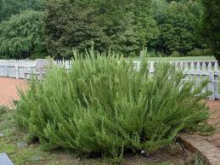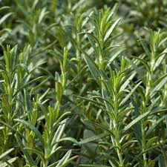

Sage: This can also grow to be quite large and only requires a small amount of leaves to have a heavy impact on food.
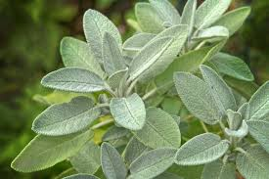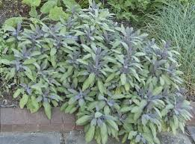

Oregano: This is a low growing shrub that has a very distinct leaf shape and is potent and powerful when fresh!
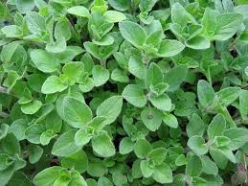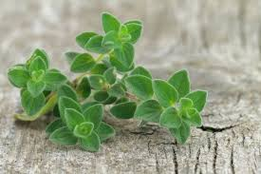

Spruce Tips: Now it isn’t the season for these tips to be young and tender like they are in the photos, but for this experiment, any new growth will still be very smelly and interesting. Just a handful can do the trick!
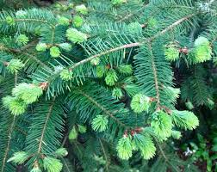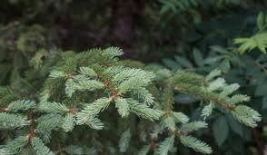

Grand Fir: This is one of my favorite evergreens of Washington. The leaves of the Grand Fir are very citrusy and are full of flavor. I usually infuse oils with grand fir, as cooking with the needles directly can lead to some very bitter meals!
