Taste Book Experiment Guide #2
Week 4 – Smell Chapter
Pp 75,76 & 77,78
Caleb Poppe; popcal18@evergreen.edu
We will be referencing Barb Stuckey’s book, Taste, again this week, and for those of you that have a copy of their own, please read through the Smell Chapter (pp 55-73). We will be walking through 2 experiments this week, a modified Nose Smelling vs Mouth Smelling on page 75&76 and the Spice Rack Challenge on page 77&78.
To prep for the experiment – I am going to ask you all to gather up some of your favorite spices used in your own home; these fresh and/or dry spices can range from thyme, basil, sage, pepper, cayenne, curry, anise, salt, even ketchup or sriracha, etc. If you don’t have access to your own spices – I encourage you to go on a walk around your neighborhood and forage for some of your own; everywhere I go in Olympia has rosemary, sage and oregano growing ‘wild’ outside. Feel free to grab some spruce tips, or my favorite: Grand fir needles. Ref: The Sioux Chef’s Indigenous Kitchen – pg 181.
Supplies you’ll need:
- Spices, fresh AND dry if possible (10 max)
- A couple of clean cups
- A rag or paper towel
- A clean piece of paper
- Paper and pencil/pen
[Taste is a required text and available for $2 online. Caleb has provided excerpts as downloads on our Tasting Research website: https://wordpress.evergreen.edu/terroirw21/2021/01/02/2-grains-wks-3-4/Links to an external site.
Spices in often inexpensive and bulk quantities can be purchased from the Oly Food Coop (west and east sides), Radiance, Buck's Spices, and Grocery Outlet.
Please mark you planners for picking up Taste Research materials including coffee, tea, and seaweed on wk 5 Tuesday, 2 Feb, between 3:15-4:30 at the campus farm. --SW]

Today’s Experiments:
- “Taste what you’re missing: Spice Rack Aroma Challenge” page 77,78
- “Taste What You’re Missing: Nose Smelling vs. Mouth Smelling” page 75,76 (MODIFIED)

Throughout these labs try and reflect on your own experience and perceptions, doing this will help you to answer the questions that coincide with this guide. It may help to have the answer sheet open so that you can record your thoughts and reflections while they are fresh in your mind. Above all, have fun.

Welcome to aroma week!

Right now, we are reading and learning about how our bodies perceive the entire configuration of taste; not only is taste that which hits our tongue, it is all of our bodily senses drinking in the meal in front of us, whether it is my grandmother’s spaghetti and garlic bread or a single California raisin; taste is the soil & culture, the passion & journey, the labor & sweat, and more, all compiled together to give us the full experience.

It is argued that roughly 75-95% of our perception of taste comes from the retro-nasal olfaction that occurs as we breath in the volatiles that are emanating from the food we are eating. Recall last week’s Jelly-Belly experiment and the power and complexity of jellybean’s flavor when allowing for our noses to do the tasting. Taken from the smell chapter in Stuckey’s book, Taste, as well as info from Sharma’s book, The Flavor Equation, we learned more about how volatiles act and react when subject to various conditions. These volatiles are what I am hoping to hone in on with you all this week!

I hope that you all had a chance to gather some dry and fresh spices, especially ones that you are keen on. If you have no spices or have a small spice collection, use this time to observe others and begin to create a list of the spices you would like to add to your collection. As we will talk about more in depth later, the sense of place that we associate with the spices we use, and more intriguing - their smell, can be hard hitting and long lasting. As we make associations with pleasant smells and fond memories, or fetid smells and less than savory memories, these ‘odor signatures’ as Stuckey refers to them, are imprinted in our minds. This imprinting is often recalled almost instantaneously when we get a whiff of a nostalgic smells. This happens to me all the time, I am transported back to a memory that I subconsciously packed away in association with a smell.

1st Experiment: “Taste what you’re missing: Spice Rack Aroma Challenge” page 77,78
In this experiment we are going to put our powers of olfactory recollection to the test! Now that we have gathered up some of our spices, I ask you to put a small amount of each spice into its own individual cup so that you have various cups each containing a single spice. If you don’t have access to any spices, this can all be done with plants and flowers that you may be able to find in your own neighborhood. Spices such as rosemary, sage and thyme are easy to identify and grow in planters all over Olympia. In addition to these, cedar, spruce and fir tips/boughs are a semi-popular culinary ingredients that can offer a wild olfactory ride!
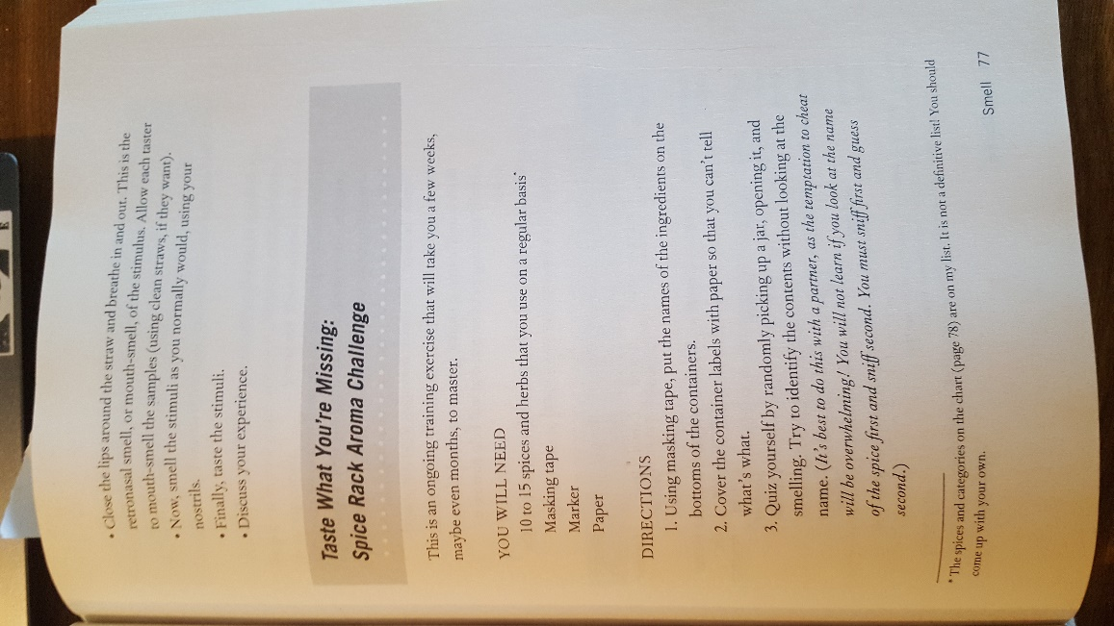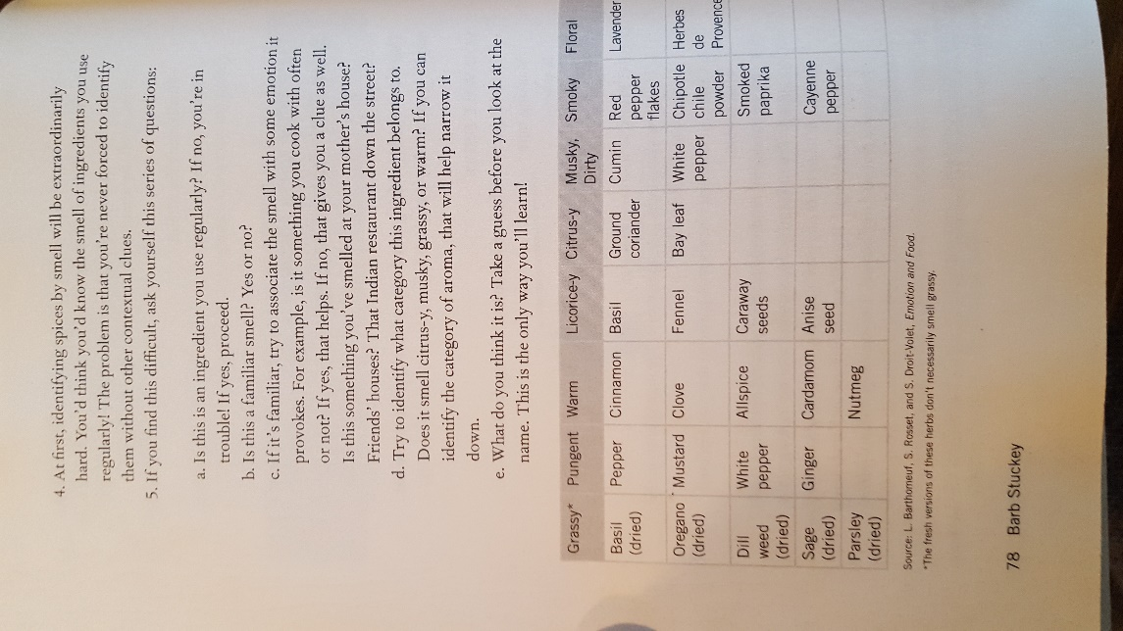
For some of your fresh spices it may be good to rub them back and forth in your hands a few times before placing them into the cup to release some of the volatiles – once the spices are in the cup, gather them close together and cover them with a rag or a towel.
Now that we have the spices staged – we are going to try and randomly pull out a cup with a mystery spice, smell it and guess which one it was! No peeking! Once you have made your guess, open your eyes and see if you were correct! (It may help to shake it up a little before smelling.) If you guessed correctly, set it aside (to use later). If you guessed incorrectly put it back under the rag and give it another go.
Do this until you have blindly guessed all of your spices!
**Challenge Stage!** With your eyes closed mix a few of the spices together and shake them up so that they become homogeneous. This may also be done with already mixed spice blends that you may have in your spice rack, with blended curry seasonings, or even with coca-cola. Once you have a few cups of mixed-up spices, cover them with the rag and go again on this whiffing challenge! Try to differentiate which spices were mixed together.
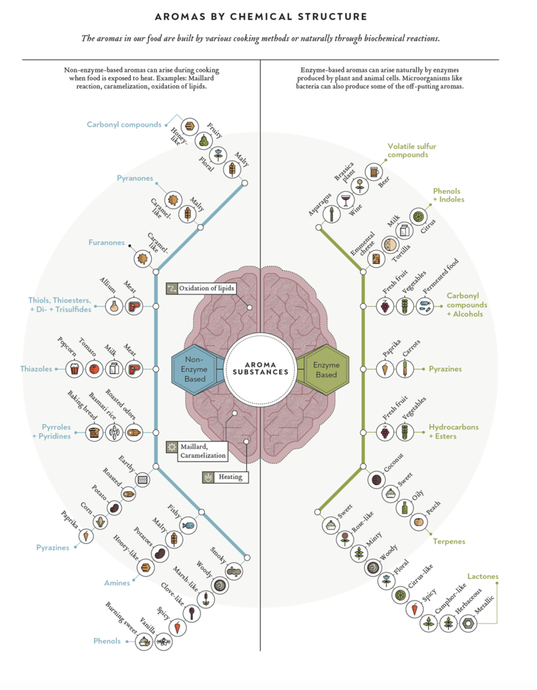

This chart was taken from Nik Sharma’s book, The Flavor Equation. It shows the relation and difference between enzymatic aromas and non-enzymatic aromas, stating that non-enzymatic aromas arise mostly from the process of heating/cooking a substance, whereas enzymatic aromas arise from the natural biochemical processes of plant and animal cells.

2nd Experiment: “Taste what you’re missing: Nose Smelling vs. Mouth Smelling” page 75,76 (MODIFIED)
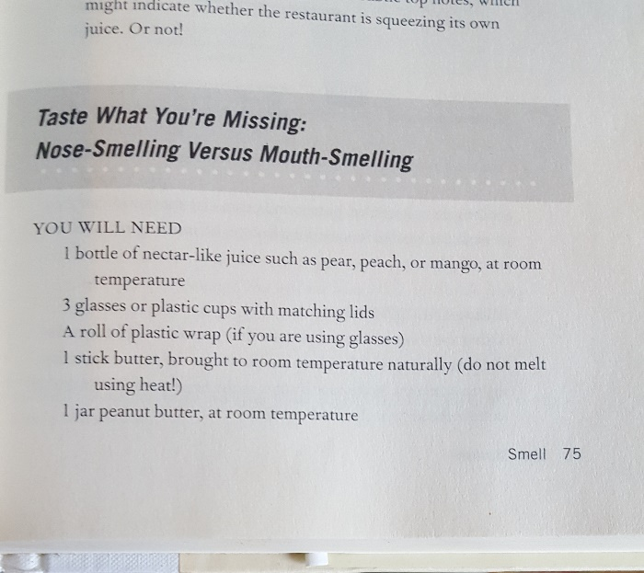
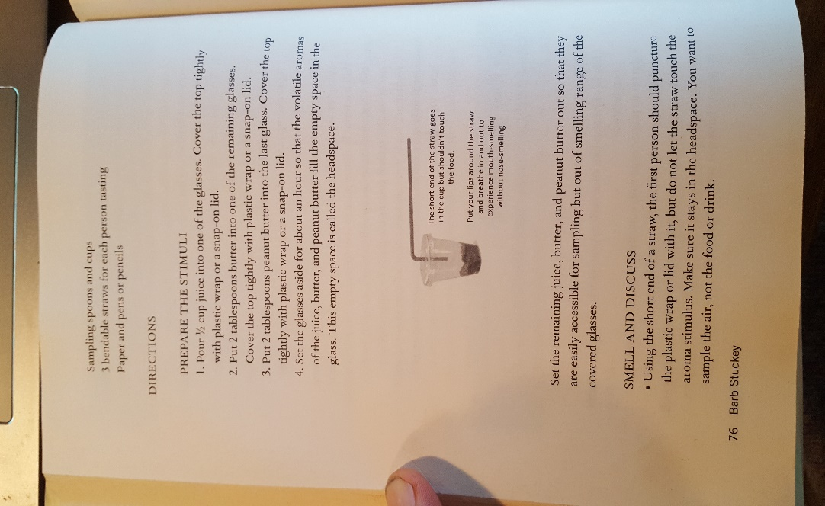

***Instead of using juice, butter, and peanut butter, I thought that we could just reuse the spice samples that we were using for the earlier experiment. Please reset your cups so that they each contain a small amount of a single spice and cover up with a rag.***
Now that we have just tested our nose’s detective ability in trying to differentiate between smells, we are going to play around a little with mouth smelling, that is, retro-nasally experiencing these spices. I asked you to have a clean piece of paper for this experiment because I thought that we could use that as a straw instead of handing out unnecessary plastic straws. Please roll a piece of paper into a straw-like structure. Throughout this experiment, it is important to keep your cups covered with any some sort of covering that you have (a rag will do fine), this will ensure that the majority of volatiles remain within the cup.
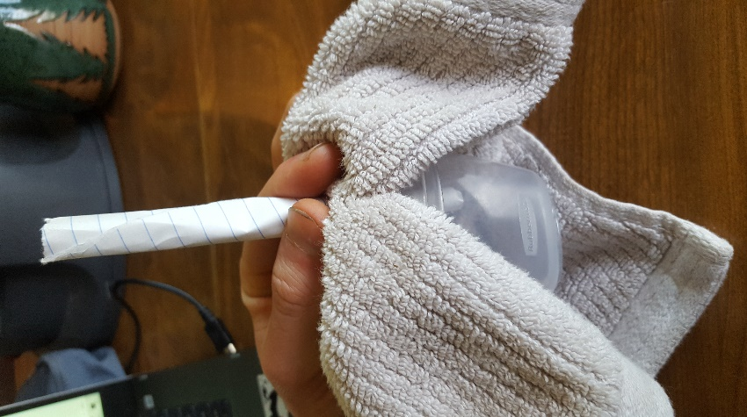
Now grab one of your spice cups and keep it covered, try to weasel your ‘straw’ under the rag so that we don’t lose too many volatiles and go ahead a breath in through the straw. IMPORTANT! Please make sure that your straw IS NOT in the actual spice but above it – we do not want to suck in a bunch cinnamon or something…
What are you experiencing? Can you still smell the spice? Do you taste it even though you haven’t eaten any of it?
Do this for each of your spices and remain reflective as you move from one spice to the next. Did these spices retro-nasally smell differently than they nose smelled? How was this different than just smelling them with your nose?
Last step, but definitely not least, go ahead and take small tastes of the spices that you have been using and pay attention to what senses are being triggered. Now at the end of today’s sessions are you able to differentiate between what is going on between your nose, mouth and tongue to bring you the complexity of flavor?

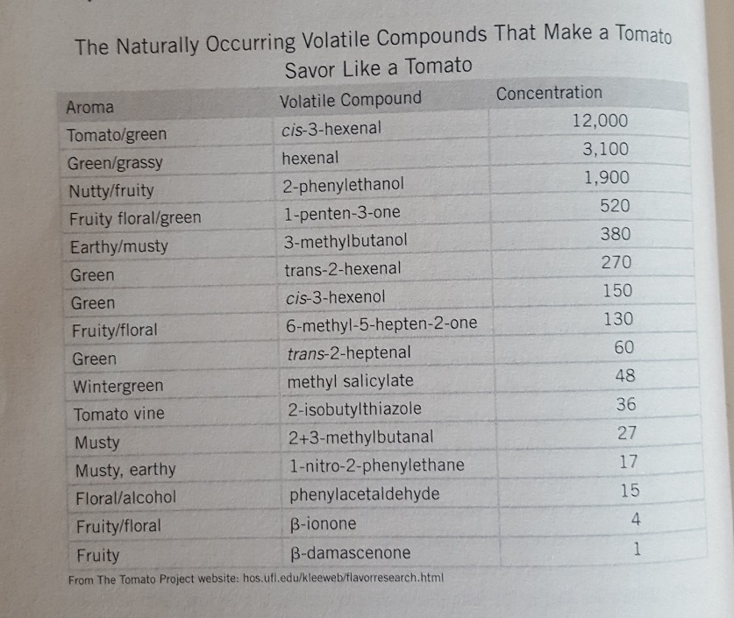
Above is a chart taken from Stuckey’s book, Taste. In the chart we are given the names and concentrations of different volatiles observed in a raw tomato – we are also given the aroma that has been associated with the different volatiles! Maybe this will help visualize why aromas between two completely unconnected items can be so similar, it all has to do with the present mosaic of volatiles and the concentrations in which we experience them.

