Taste Book Experiment Guide #1
Week 2 – Taste Chapter
(pgs 30, 40, 52, 53, 54)
Caleb Poppe; popcal18@evergreen.edu

The experiments done in this lab are all taken from Barb Stuckey’s book, Taste.
In this lab we will be walking through 4 experiments that focus on our own personal perception of how we taste the foods that we enjoy. Knowing that we all come from different cultures, heritages, and backgrounds, we too must know that these have a powerful effect on how our individual mind and body interact with the food we use to fuel them. With that being said, we all share common ancestors, and our bodies may have a lot more in common than we at first bel
Today’s Experiments:
- “Taste What You’re Missing: 5 Minute Raisin d’etre” – page 347
- “Taste what you’re missing: Your Taster Type” – page 30
- “Taste What You’re Missing: Separating Taste from Smell” – Page 52&53
- “Taste What You’re Missing: Sour all Over” – page 53&54

Throughout these labs try and reflect on your own experience and perceptions, doing this will help you to answer the questions that coincide with this guide. It may help to have the answer sheet open so that you can record your thoughts and reflections while they are fresh in your mind. Above all, have fun.

1st: Taste What You’re Missing: 5 Minute Raisin d’etre – page 347

As Stuckey says at the beginning of this section: “we often take meals for granted...”, often rushing through the process of eating a meal and seldom slowing to eat at such a pace that allows us to stop and fully contemplate the meal and its entire story of how it made it to our mouths. In this experiment we are going to go to the other extreme and go super slow-mo through the act of eating only 3 raisins:
Inspect each raisin and think about how it came to look like that having once been a plump and juicy grape.
Once you put the raisin in your mouth, hold it there awhile and think about where it came from (Cailfornia soil).
Try and make all 3 raisins last 5 whole minutes!

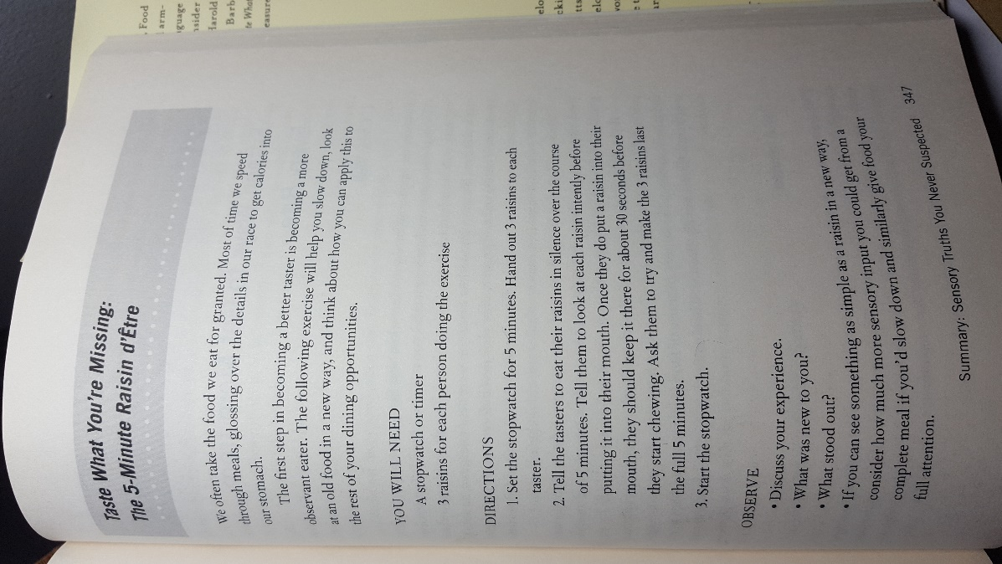

2nd: Taste what You’re missing: Your Taster Type – page 30

In this experiment, we are going to try to better understand the topography of our tongue. It is safe to say that a whole range of factors attribute to how many tastebuds our individual tongues have, and while tastebuds only play a small role in our perception of taste, they are no doubt vital. Using the quetips that were provided to you, dip them into the blue dye, coating the entire cotton swab so that it is saturated, and dab an area on your tongue about the size of a nickel and place the binder saver ring on the dyed area of your tongue. Using your phone or a magnifying glass, try and count the number of taste buds that fit inside of the binger saver ring. *It may be best to do this in front of a mirror so that you can see what you are doing*
In the book, we are given a key as to how we interpret the number of tastebuds we count in the binder ring – in its important to remember that these numbers are subjective AND there is no way to know if the binder savers we are using are they same width as the ones used in the book.
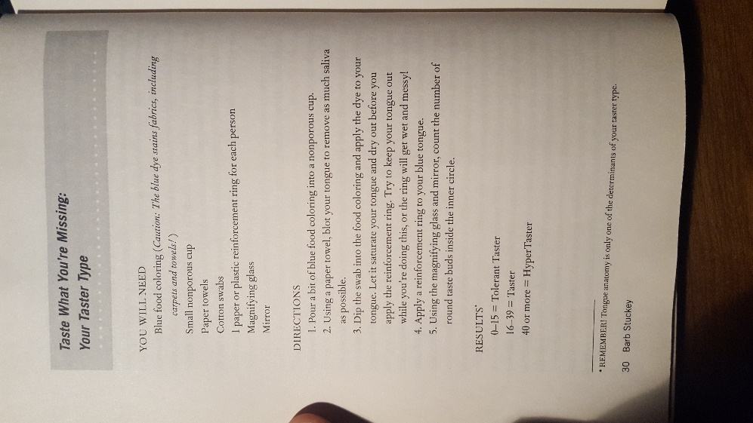

3rd: Taste What You’re Missing: Separating Taste from Smell – Page 52&53
We may all remember hearing at some point the line “…plug your nose, it’ll go down easier” maybe in reference to taking cough syrup as a child or eating overpowering, stinky foods. As we learned last quarter, the majority of how we perceive taste lies within the aromas that we inhale as we eat a meal; holding our noses closed greatly reduces the amount of aromas that travel into our nasal passage, the location where aromas are detected. In this experiment we are going to try and pick out what we are tasting when we eat very flavorful foods with our eyes and noses closed. Jellybeans are sweet, colorful, and packed with flavor, but how much of the jellybean are we tasting with our mouths and how much are we tasting with our eyes and nose?
From the jellybeans that we provided, and with your eyes closed and your nose plugged, pick a random jellybean, put it in your mouth and give it a couple chews to release the flavor – then unplug your nose and take a steady breath in, paying close attention to how this changes your perception of the jellybean. Could you tell what flavor jellybean you had chosen before you unplugged your nose? What specific senses of taste were being triggered?
Cleanse your palate and repeat a few times.
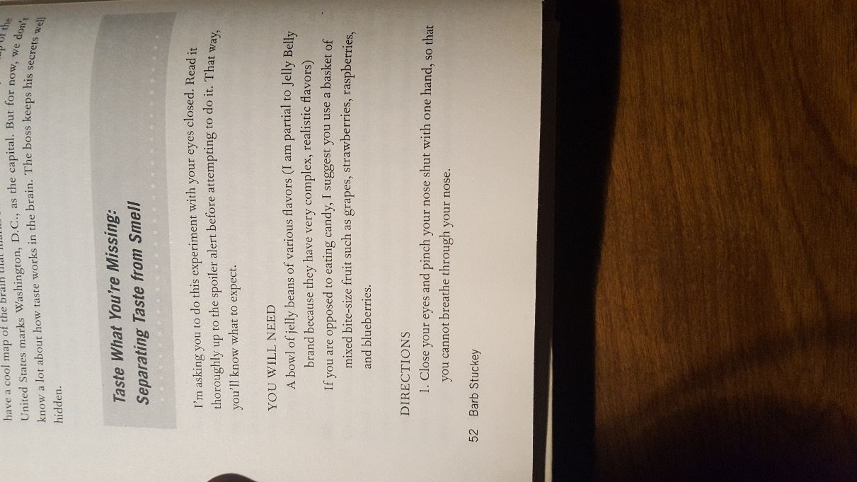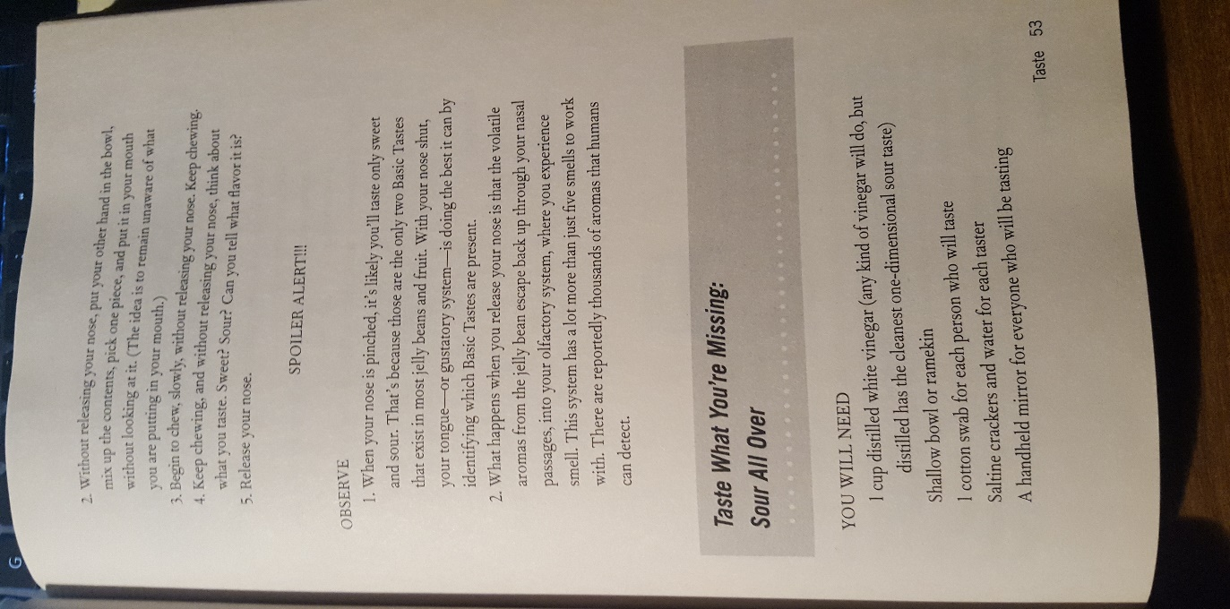

4th: Taste What You’re Missing: Sour all Over – page 53&54

While some may argue that certain parts of our tongue are better equipped to identify certain types of taste (sweet, sour, etc.), it is rather easy to prove we can experience each of the 5 basic tastes on all parts of our tongue. In this experiment, we are going to do just that. With the quetip and the vinegar, a highly sour/acidic substance, swab your tongue in different locations and pay attention to where the sour flavor is most and least heightened. Do you recognize any correspondence with your vinegar swabbing and the map of the tongue on page 54?

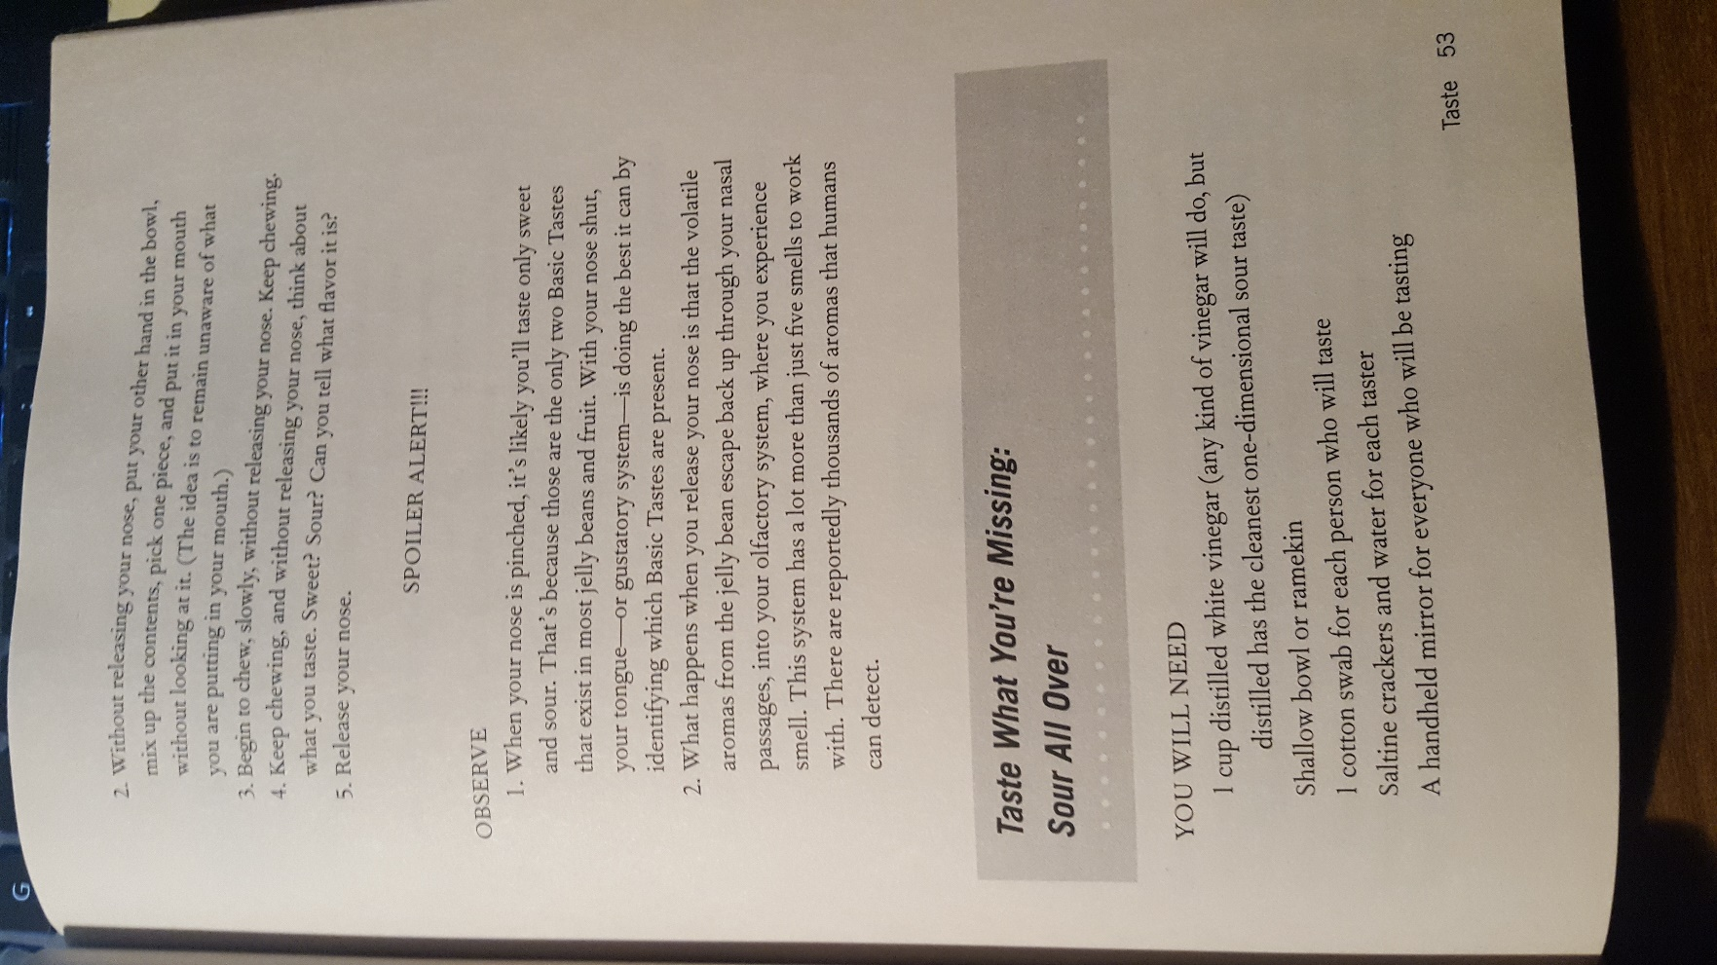

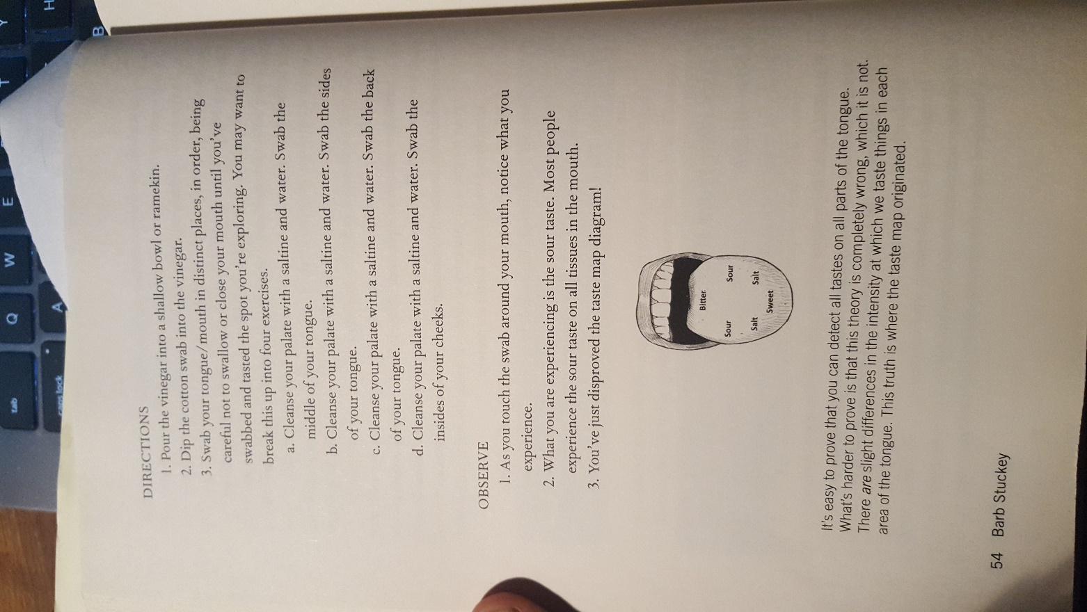

That’s it!
Don’t forget to fill out the question/answer form that goes along with this lab!

