Minimum Requirement Plan B Option for Winter Quarter Start Students

The Cooking Gene in Review as a Foodoir Blueprint

Reviews and Website--Afroculinaria:

https://afroculinaria.com/about/

Antebellum Chef: How is what you eat prepared?
Kosher/Soul: What is your individual/lineage’s religion, ethnicity, culture, soul?
Identity Cooking: Histories, Tastes, Flavors, (Im)migration related to your sense of self/place?
The Cooking Gene: How is terroir is in your genes?

“Identity cooking isn’t about fusion; rather its how we construct complex identities and then express them through how we eat. Very few people in the modern West eat one cuisine or live within one culinary construct. Being Kosher/Soul is about melding the histories, tastes, flavors, and Diasporic wisdom of being Black and being Jewish.

The Cooking Gene is Michael’s personal mission to document the connection between food history and family history from Africa to America, from slavery to freedom

Terroir is in your genes”

Twitty’s Website: Afroculinaria

- https://afroculinaria.com/about/

- http://opentranscripts.org/transcript/culinary-injustice-reconciliation/

- https://afroculinaria.com/tag/the-cooking-gene/page/2/

VIDEOS:

https://www.google.com/search?q=MICHAEL+TWITTY&client=firefox-b-1-d&sxsrf=ALeKk00t_0z-ZAHKsQgYQigzzTy7R55rlw:1611122568275&source=lnms&tbm=vid&sa=X&ved=2ahUKEwj2hPyi66nuAhUhPn0KHTBwAYcQ_AUoAnoECAgQBA&biw=1282&bih=738

Prompts from Fall Quarter (Follow canvas link: “Taste: Food Labs” for student examples)

Wks 1-2 from Winter “Taste: Case Studies”

#1h: Foodoir: Your Story of Tasting Place
Here’s where you write (draw, cook, scan, photograph, document) your engagement with the foodoir of your choice. Always begin by providing 1-3 sentences of a key quote from your foodoir (with author, title, page #) that you’ll be responding to by creating your own story of taste and place. Create a reading schedule week one in order to read approx. 1/9 of the book each week. Choose your ONE foodoir from this list (also provided on the TM syllabus): Farming While Black by Leah Penniman, The Rise: Black Cooks and The Soul of American Cooking or Yes, Chef: A Memoir by Marcus Samuelsson, The Flavor Equation by Nik Sharma, The Gastronomical Me by M.F.K. Fisher, The Sioux Chef’s Indigenous Kitchen by Sean Sherman.
If you’re new to TM winter quarter another option is to read the fall TM foodoir, Michael Twitty’s The Cooking Gene following the prompts provided on the fall quarter website. SW will be providing a prompt from Harold McGee’s Nose Dive each week, which students can choose to juxtapose with their foodoir quote, or not. Nose Dive locates the human sense of taste in relation to the evolution of plant earth. It also provides a blueprint for doing taste research, beginning and ending with McGee’s story of tasting grouse. All students will be supported to develop independent research projects for 4-12 credits during the spring quarter, or sooner as your interests take form.
Quotes from fall quarter’s weeks 1&9 reading from The Cooking Gene
Michael Twitty
“The Old South is a place where people use food to tell themselves who they are, to tell others who they are, and to tell stories about where they’ve been (xii).
The Old South is a place where food tells me where I am. The Old South is a place where food tells me who I am. The Old South is where food tells me where we have been. The Old South is where the story of our food might just tell America where it’s going (xvii).
’We need a blueprint as individual and as a people’ (11).
‘What’s the best thing you ever cooked?’ I asked my mother.
‘A little black boy named Michael; I cooked him long and slow,’ she replied (13).
The disruption of the black family, the interruption of an important community-driven ethnic economy, the engendering of a poor diet, an urgent desire to suppress learning and education, and a culture of unrelenting violence–these and all the dependency, instability, and toxic thinking that wen along with them were the fruits of King Cotton, none of which black America has been able to fully purge from its system. (358)
Little bits of stories mixed with recipes and techniques, treats, and tips come out as she rehearses the family dead in her mind: how to wash collards, sorting through field peas, the right way to chew sorghum and sugarcane …. (360).
Our food was never just food. (365)
Michael Twitty
Like our program’s focus on terroir/meroir, the focus of Michael Twitty’s The Cooking Gene is food and place. But, for Twitty understanding the taste of place requires being able to tell a story that locates the storyteller in relation to food and place. The Cooking Gene as a food memoir is part of a rapidly growing field of popular and academic interest in the intersectional politics of food. During fall quarter we read The Cooking Gene as a “blueprint” for writing our own “foodoirs.” During winter quarter you read the story of your choice of an author’s identity as an eater, consider your own story of self, food, and place. In what ways does (and doesn’t) your author’s writing provide a blueprint for yours? What do you choose to eat and why? Who cooked you and who cooked for you? How has that cooking—and its history–shaped your taste preferences and experiences? As you experiment with crafting words to communicate your taste experiences be sure to include that process in your story. What characterizes your experience of the relationship between your mouth as an organ of ingestion and an organ of disgestion? How do your hands relate to your mouth and to your keyboard? Where, when, and how is your thinking embodied?
The final part of your Tasting Lab post each week should include writing toward your own foodoir. Ground/anchor your writing in relation to a specific quote (or series of quotes) from each week’s chapters from The Cooking Gene or the foodoir of your choice. Note: Like his book, Twitty’s WordPress website, Afroculinaria, is award-winning. What about both inspire you? Suggested Length: 100-200 words.
Have you chosen your foodoir text? Here are a couple relevant images from Sharma’s The Flavor Equation re: week 2’s “taste bud” experiment:
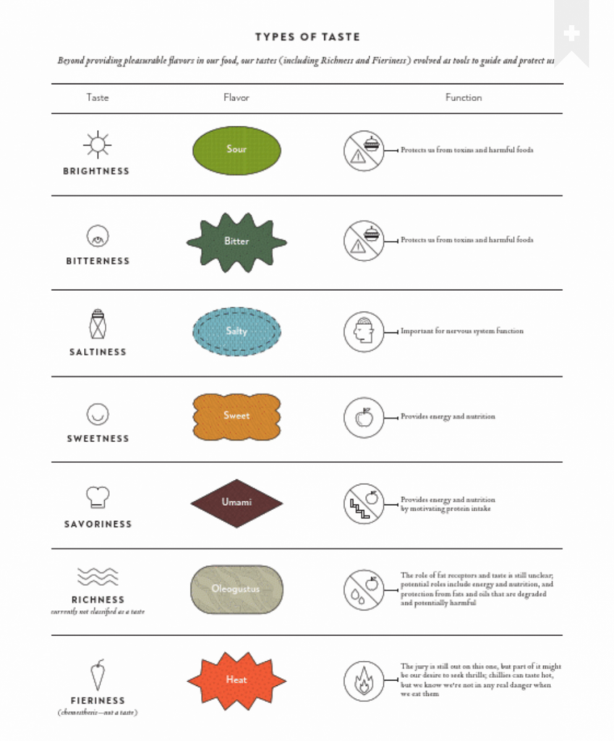Sharma’s The Flavor Equation p 49 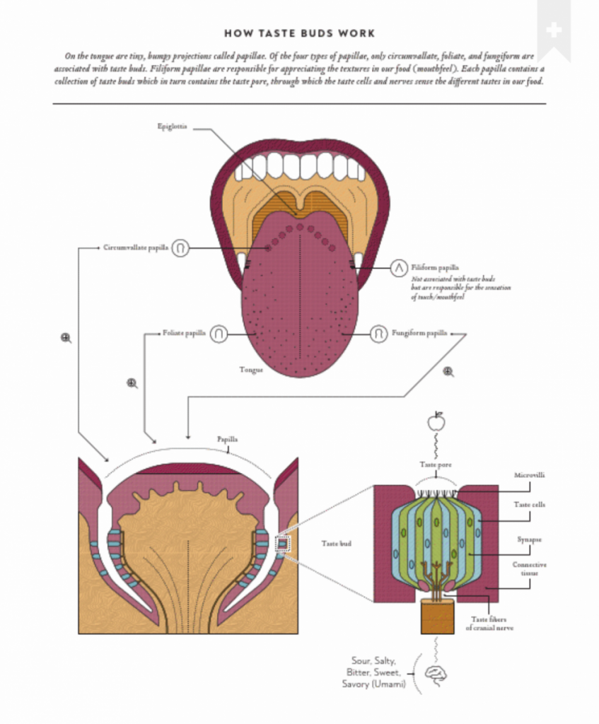Sharma’s The Flavor Equation p 51

Wks 3-4 from Fall Taste: Food Labs

Assigned Chapters of The Cooking Gene: ch 3-4
My daddy was the first to make me taste Virginia. Actually, he shoved it into my mouth before I could say no. … He dug into the soil of an exposed hillside looking for a perfect, unblemished nugget of Prince Edward County red clay. I had no idea my father, who I felt was mostly sane, was about to feed me dirt (44).
Jewish food and black food crisscross each other throughout history. They are both cuisines where homeland and exile interplay. Ideas and emotions are ingredients–satire, irony, longing, resistance–and you have to eat the food to extract that meaning. The food of both diasporas depends on memory. One memory is the sweep of the people’s journey, and the other is the little bits and pieces of individual lives shaped by ancient paths and patterns. The food is an archive, a keeper of secrets (70).
In Jewish culture, much like continental African and African Diaspora cultures, food is a mnemonic device. [O]ur food has not just been fodder for our journeys, but embodies the journeys themselves (72).
Michael Twitty, The Cooking Gene

Wks 5-6 from Fall Taste: Food Labs

#5b: Foodoir: Your Story of Tasting Place

Assigned Chapters of The Cooking Gene: ch 8-9
All I ever really wanted was a recipe of who I am and where I come from. (120)
[M]y dream was to be able to put myself in the evolving narrative of Southern food from its beginnings to now, and to do so I had to be able to do what most African Americans had the most difficulty doing–trace my ancestry to Africa and follow the lineages across the Southern map into the present day. (125)
‘Who are you and what does the plate of food you put before me communicate to us who you are?’ … My answer is plain: my food is my flag. (138)
It wasn’t just liquid, it was the rarest and most special taste in nature. (142)
[A] man having relations with sugarcane begat the rest of humanity. (142)
To scholars of food, race, and economics, the work of Sidney Mintz, among others, is a powerful indictment of the way in which taste can become political and sway the stories of nations. (142)
One hundred ten gallons of rum might purchase an adult; 80 might purchase a child. (149)
Michael Twitty, The Cooking Gene

Wk 7-8 from Fall Taste: Food Labs

#6b: Foodoir: Your Story of Tasting Place

Assigned Chapters of The Cooking Gene: ch 10-11
Many of the building blocks of soul food were key to the central African diet and continued in the Low Country unabated and given the similarity of these foods to those found in West African–a common tradition could be built across vast linguistic divides. (188)
To this day most of American rice is raised in six states, four of which were settled by the French during the colonial period with West African slave labor with rice-growing knowledge. (193)
Just as people have genealogies, so do plants. (200)
Food was often expressed not as a thing in these cultures but as a member of your family. (204)
The slave trade was timed to make deliveries of enslaved Africans in tune with the agricultural cycle, especially those of maize, rice, and yams. (208)
Michael Twitty, The Cooking Gene

Wk 9 from Fall Taste: Food Labs

#8b: Foodoir: Your Story of Tasting Place

Assigned Chapters of The Cooking Gene: ch 14-16
I learned the most about food when I had the least amount of money to spend on it. The years without were not romantic. I just had no choice but to draw on tradition to get me through. Instead of nightly scrounging to find cents for taco money, I made a pilgrimage to a hardware store in Orange, Virginia, and bought bulk Southern heritage seeds from jars lodged in a wooden cubbyhole system. (265)
Long before anyone heard of a “victory garden,” Africans in America, South and North, were no strangers to the truck patch or provision garden. (266).
Long before the current movement to taste the past an revive forgotten terroir, it made sense to me that the Caseknife pole bean from Wesley and the Cowhorn okra from Peter and the yam potato from William were something more than just near relics. They were the very taste of how my ancestors survived slavery. This–the variety, the flavors, the shiny Green Glaze collards and Amazon tomatoes–this was the taste of proto-soul. (268)
‘History is the missing piece.’ (277)
The gardens were more than just sources of nutrients; they were spaces where the medicinal and spiritual practices cold be kept alive. (269)
Your gut is your primal brain; all the intelligence of your ancestors is in your gut and genes. Your food and environment are like fingers on a light switch turning genes on and off. (279)
There was nothing in the animal kingdom that did not speak to us. (302)
As a tool of political coercion, barbecues were used in early Southern culture to foment connections between planters and their families, and later became a critical ingredient in the performance of political rallies and the selling of candidates. (312)

Wk 10: Curated from previous for final integrative presentation. Use WordPress or PPT for final presentation.

