Huyen Pham

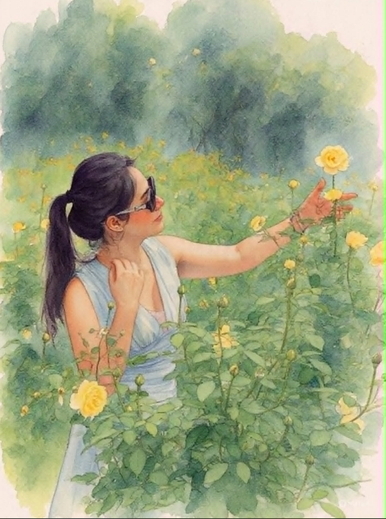

I cannot remain indifferent to these beautiful roses, exuding their sweet scent and displaying their colors in this peaceful natural setting.

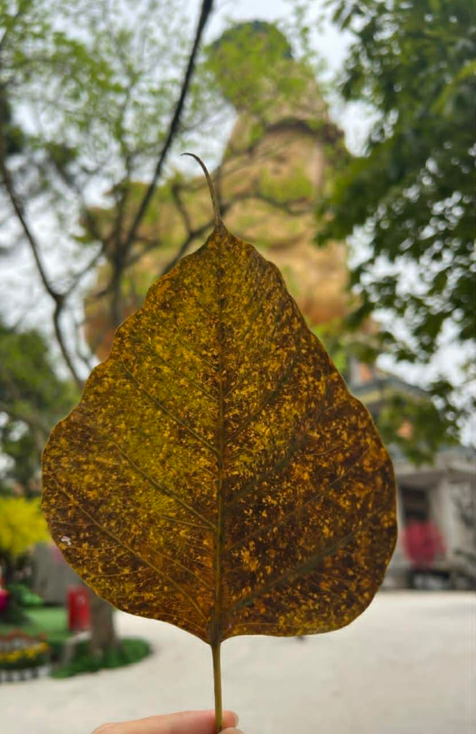

The leaf falls from the branch, yet it does not abandon beauty. In the light, it becomes a golden painting, each vein a pathway leading to hidden realms.

It trembles softly, whispering of its youthful days, of mornings that welcomed the sun, of rains it once embraced.

Now, no longer part of the vast canopy, the leaf turns into a miniature universe, where light and memory intertwine, telling the stories of wind, of sunlight, of time.

And the one who cherishes it suddenly understands: sometimes, separation is not an ending, but another way to shine.

