Hope and Healing
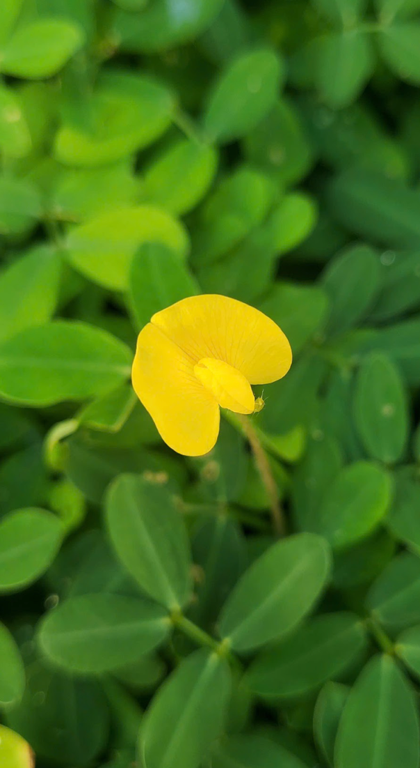
I find a great sense of peace in the yellow flower against the green leaves, and I hope it brings a similar feeling to others.
Ms. Nhu

