Four Seasons, One Earth — Mutual Healing with My Dog.

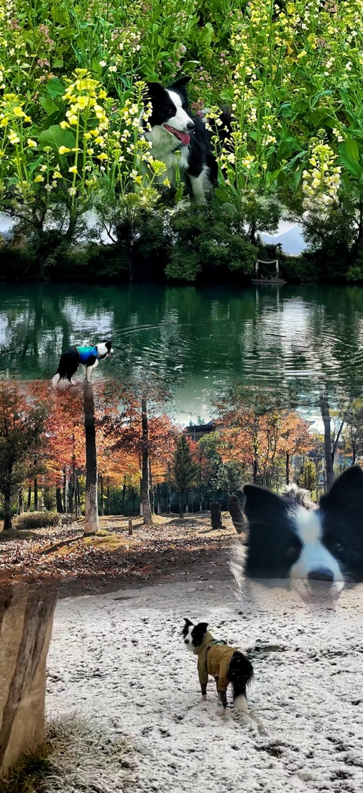

These photos show my local four seasons and my dog. We walk, rest, and connect with the earth together. Every season teaches us patience, care, and mutual healing. By loving nature and animals, we heal the earth and ourselves.
Jia Wei

