Radicchio
Cichorium intybus v. Latifolium

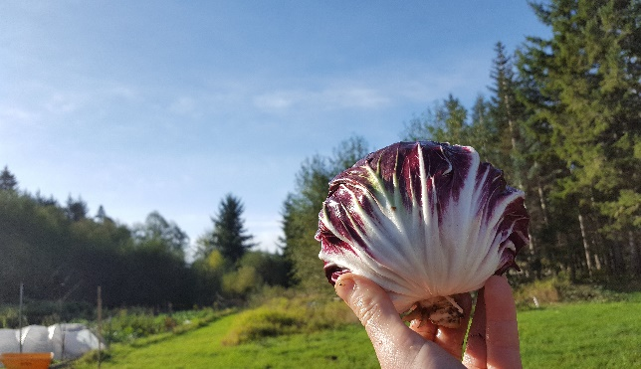
Variety: Sirio, a red Chioggia type of radicchio. photo by Caleb Poppe

Introduction
There are 4 commonly cultivated biotypes of chicory within the species Cichorium intybus: Root Chicory, Forage Chicory, Witloof (etiolated) Chicory, and Leaf Chicory aka Radicchio; the subject of this composition will look exclusively at the Leaf Chicory types of C. intybus and is written from the perspective of temperate climate, Pacific Northwest (PNW) growers.
While radicchio is a biennial crop, it is commonly cultivated as an annual and harvested for its tightly packed head of leaves. This crop is well known for its ability to withstand harsh winter conditions and is praised for its slightly bitter taste as a hearty and nutritional winter crop. Radicchio can be prepared in many ways but is commonly enjoyed sauteed or eaten raw.

Table 1:Taxonomy of Cichorium intybus, including subspecies, botanical varieties, and cultivar groups (Gianni et al. 2016)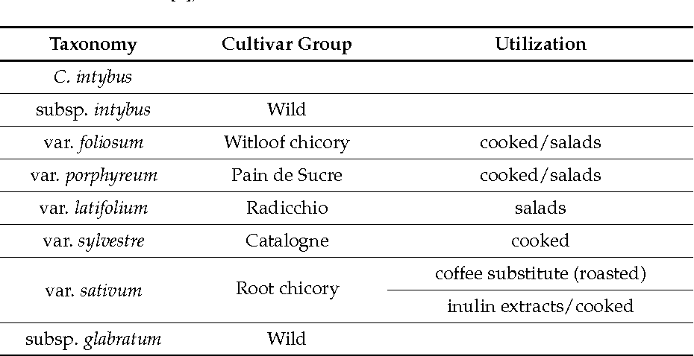

Italian Origin Story:
Beginning in the late-16th century, Italian radicchio began its journey of domestication and cultivation. It is believed that, for centuries, the commonly cultivated radicchio was most closely related to the Rossa Di Treviso Tardivo biotype. Eventually, in the early 1900’s, Italy began breeding efforts that gave rise to the regionally iconic varieties of radicchio that are popular in the market today; for instance, the biotype ‘Rossa Di Chioggia’ in Italian means: Red of Chioggia or, the red radicchio from the Chioggia region of Italy. Most of these biotypes, progeny of the Rossa Di Treviso Tardivo, have been bred through mass selection, chosen for their desired traits, and only considered true to type when maintaining certain characteristics.

Leaf-Chicory Biotypes:
- Rosso Di Chioggia – Large, perfectly round head and imbricated heads with slender, all white midribs and red lamina. Large varietal diversity makes this type ideal for year-round production.
- Rossa Di Verona – Smaller, imbricated, egg shaped heads with wide, all white midribs; leaves are deep red with a unique texture. This type contains varieties that fare well in both early season and late season conditions.
- Rossa Di Treviso Precoce – Large, imbricated, and oblong shaped heads with very wide, all white midribs and deep red lamina. This type contains varieties that fare well in both early season and late season conditions.
- Rossa Di Treviso Tardivo – Medium sized heads that consist of individual leaves that stand upright, only beginning to curl inward near their apex. Leaves are thick with wide, all white midribs; best suited for late season/winter harvest.
- Variagato Di Castelfranco – Medium sized, tightly packed rosettes consisting of creamy yellow inner leaves with variegated splotches of light-red coloration. This type is commonly planted in late summer and harvested well into the winter.
- Pan Di Zucchero (Sugar Loaf) – Large and tall, cylindrical heads of imbricated leaves that are all green. This quick to maturity type fares well in all seasons but is markedly less cold tolerant.
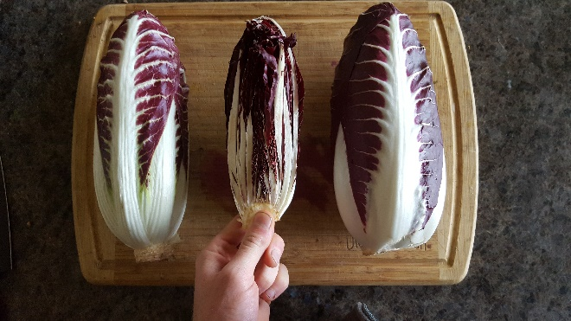
Rosso di Treviso Precoce, photo by Caleb Poppe
Seed Saving & Breeding:
Radicchio plants are self-incompatible meaning that the flowers of a single plant cannot self-pollinate, leading to difficulties in obtaining inbred, F1 hybridized radicchio varieties. Because of this, open-pollinated (OP) breeding and land-race varieties are the standard breeding options in radicchio seed production.
Due to the high variability of radicchio biotypes, and the diversity of seasonal and climatic requirements, seed saving procedures can vary from one type to the next. Considerations need to be made regarding the days to maturity and time of planting when making plans to save OP radicchio seeds. Leaf-chicories are biennial and need to be properly vernalized to ensure viable seed production and once the plants have gone to seed, they will need a period of dry conditions to ensure for proper seed maturation and drying.
For the cold-hardy, late season varieties, timing your plantings for mid-fall will allow for spring-time seed harvests. For early season varieties that may not survive an entire winter, plantings can be done in January or February to allow for proper vernalization; the seed may be harvested by June or July.

Establishment:
Planting radicchio in the Pacific Northwest is often started in a greenhouse to be transplanted into a prepared bed. In a 30-inch-wide bed, planting 2 rows (offset) and maintaining a spacing of 12-16 inches between plants will give sufficient growing space. If possible, dripline irrigation offers the most direct and efficient delivery of water to the plants; radicchio prefer well drained soils.

Management:
The transplanted radicchio can be regularly irrigated, but once the plants are well established, the frequency of irrigation can be reduced to only watering when needed; soil texture should be accounted for when planning irrigation timing. The beds can be weeded as needed to reduce competition with other weeds. Most varieties of radicchio do not call for special treatment and may be harvested when the heads have reached a full size, removing the outer leaves so that only the desired head remains.

Nutritional Suggestion:
In a bed that has healthy levels or organic matter, it is suggested that addition N-P-K be incorporated prior to planting. Suggested levels:
N: 0.12lbs/100ft²
P: 0.14lbs/100ft²
K: 0.20lbs/100ft

Diseases:
Powdery mildew (Erysiphe sp.) and Downy mildew (Peronospora parasitica pers.) are common PNW diseases known to affect radicchio. Infected leaves and/or plants should be removed from the field to slow the spread of these two diseases, as well as frequent weeding and wider spacing to allow for good air flow between plants.

Pest:
Multiple species of aphids are known to infest radicchio, these include: Myzus persicae, Brevicoryne brassicae, and Lipaphis erysimi. If populations remain small, directly spraying pressurized water from a backpack sprayer can remove the aphids. When populations get too high to be manually removed, the plant should be taken from the field and destroyed to avoid further spread of the pests. Physical barriers such as light weight row covers can also reduce populations of aphids.
Another very common pest in the PNW are slugs; especially when the plants are young and tender, slugs can do some heavy damage. Among many slug remedies, gritty materials such as coffee grounds or oyster shells have been known to deter slugs due to the course texture of the material.

Climate Importance of PNW:
Living, eating, and growing in the PNW offers many unique opportunities in all aspects of life. This moist, temperate, evergreen wonderland is busting at the seams with life, yet this ever-changing environment is amid some accelerated changes that threaten to have detrimental and irreversible worldwide impacts. The Intergovernmental Panel for Climate Change (IPCC) has been consistently warning world leaders for years of the need for unified action in the face of ongoing climate change. Yet, even if drastic actions were taken to immediately address climate change, the theory of “energy inertia” shows that the emission projections for the next few decades will continuously rise, having continuous adverse effects.
This is all to say that changes will continue to affect the world in many ways, some of which are still being researched to be better understood. In the PNW, it is projected that by the year 2100, in the highest emission scenarios, average regional temperatures could rise 7℉ – 10℉, precipitation amounts could increase by 10 - 15%, and the waters of the Puget Sound Basin could rise by a staggering 22 inches. Along with these impacts will come unprecedented weather events during obscure times of the year; for example: unexpected frosts that come later into the spring, heavy precipitation events that could damage crops, and longer drought conditions in the summers.
In the face of these changes, small to medium scale farmers are learning and adapting so that they may be more prepared (and creative) when facing these unknowns. To add to the farmer’s preparedness, organic vegetable breeders are working to provide varieties of fruits and vegetables that are equipped to thrive in the regions they are meant to be grown in; varieties that can withstand harsher and unpredictable conditions.
Radicchio is a crop that, due to its hardiness, diversity, and beauty gives farmers another tool in their belt, so to say, when becoming malleable to the oncoming climate changes. This crop may be grown in the slack seasons when most crops are long gone, offering farmers a potential source of income while producing a local vegetable option that can go to nourishing the local community that appreciates it. Adding radicchio to a farmer’s crop plan also makes it so that less leafy greens need to be shipped to this region in the off season, and if timed correctly, radicchio can be produced year-round!
As OP breeding efforts continue to diversify, so does the bounty that farmers will have to offer to their customers.

References

AR6 Synthesis Report: Climate Change 2022 â. (2018). IPCC. https://www.ipcc.ch/report/sixth-assessment-report-cycle/
Barcaccia, G., Ghedina, A., & Lucchin, M. (2016). Current Advances in Genomics and Breeding of Leaf Chicory (Cichorium intybus L.). Agriculture, 6(4), 50. https://doi.org/10.3390/agriculture6040050
Culinary Breeding Network, & Ghedina, A. (2020, October 24). HISTORY: Radicchio Cultivation and Types. YouTube. https://www.youtube.com/watch?v=zECAQQuhq6E&t=306s
Francke, A., & Majkowska-Gadomska, J. (2008). Effect of Planting Date and Method on the Chemical Composition of Radicchio Heads, 13(2), 199–204. http://yadda.icm.edu.pl/yadda/element/bwmeta1.element.agro-article-e4b5679b-1a43-4218-a368-5a5b0a440e70
Mote, P. W., & Salathé, E. P. (2010). Future climate in the Pacific Northwest. Climatic Change, 102(1–2), 29–50. https://doi.org/10.1007/s10584-010-9848-z
Mucci, K. (2020, April 2). A Chicory to Dismantle Late-Stage Capitalism - Heated. Medium. https://heated.medium.com/radicchio-is-having-a-moment-in-the-u-s-df9cb4bf72a5
Program, S. C. C. U. S. (2015). The Effects of Climate Change on Agriculture, Land Resources, Water Resources, and Biodiversity in the United States (SAP 4.3). CreateSpace Independent Publishing Platform.
Radicchio. (2020, May 14). Smarties. https://www.smarties.bio/en/product-details/radicchio/
Rana, M. K. (2017). Vegetable Crop Science (1st ed.). CRC Press.
Street, R. A., Sidana, J., & Prinsloo, G. (2013). Cichorium intybus: Traditional Uses, Phytochemistry, Pharmacology, and Toxicology. Evidence-Based Complementary and Alternative Medicine, 2013, 1–13. https://doi.org/10.1155/2013/579319
The Editors of Sunset. (2012). The New Sunset Western Garden Book: The Ultimate Gardening Guide (Sunset Western Garden Book (Cloth)) (Revised, Updated ed.). TI Inc. Books.

